**CHAPTER I**

# **INTRODUCTION**

## **Background of the Study**

In today's fast-paced world, efficient recruitment processes are essential for public service offices to attract qualified candidates and fulfill their staffing needs. Traditional methods, such as job postings on bulletin boards or print advertisements, may not be effective in identifying the best-fit candidates due to their lack of speed, reach, and data analytics capabilities. Job portals have emerged as a popular solution, but existing ones may only cater to some of the specific needs of public service offices.

The project aims to investigate and develop an automated job portal that incorporates advanced data analytics to enhance the recruitment processes of the public employment service office in Lipa City, Batangas. A comprehensive literature review will draw on credible sources such as scholarly journals, authoritative books, and research papers. The literature review will provide a foundation by examining the significance of job portals in the recruitment process, including their automated features and the potential benefits of integrating advanced data analytics.

The study will also explore the advantages of using automated job portals with advanced data analytics, such as improved efficiency, accuracy, and transparency. Through case studies and expert interviews, the project will generate insights and recommendations for the design and implementation of PESO-NET, with the ultimate goal of enhancing public service office recruitment in Lipa City, Batangas.

Furthermore, it is essential to highlight that the Public Employment Service Office in Lipa City, Batangas is a government agency tasked with providing employment services to the local community (PESO, 2023). As a one-stop shop for job seekers and employers, PESO facilitates matching job openings with qualified workers. PESO also offers job placement assistance, labor market information, skills training programs, and career counseling (PESO, 2023).

Jobseekers can register with PESO, and avail of its services, including job matching, job referral, and job fair participation (PESO, 2023). Similarly, employers can register with PESO to avail of its recruitment assistance services, which include job posting and applicant profiling (PESO, 2023).

However, one of the predominant issues concerning contemporary recruitment processes is the extensive reliance on manual methods. Such methods typically entail the laborious task of sifting through plentiful stacks of resumes and applications, conducting paper-based tests and interviews, and manually verifying references. As a consequence, these processes are time-consuming and susceptible to human errors, leading to delays in the selection process. Moreover, the absence of a standardized system for evaluating and comparing candidates can result in inconsistencies, difficult to make fair decisions, and potential favoritism.

Another challenge lies in the conventional approach to recruitment, which may not fully harness modern technologies and strategies. The lack of automated recruitment tools, such as online job portals and applicant tracking systems, may curtail the organization's ability to manage the recruitment process efficiently and effectively screen and shortlist candidates. Furthermore, this limitation can result in missed opportunities to tap into a wider talent pool and attract highly qualified candidates who may prefer more digitally-driven recruitment methods.

Thus, the project aims to develop a specialized job portal tailored for the Public Employment Service Office in Lipa City, Batangas, Philippines. The PESO-NET platform will leverage advanced data analytics techniques to enhance the recruitment process and provide a user-friendly interface for job seekers and employers, aligning with the United Nations' Sustainable Development Goals (SDGs), particularly the 8th SDG which emphasizes Decent Work and Economic Growth (United Nations, 2015).

By emphasizing data-driven approaches, the project can lead to more effective and efficient hiring decisions, potentially reducing unemployment rates and promoting regional economic growth. The use of technology and advanced data analytics can streamline the recruitment process, enabling public service offices to identify and hire qualified candidates more efficiently. This can contribute to economic growth by creating a more skilled and productive workforce, aligning with the goal of economic growth as outlined in the 8th SDG.

## **Objectives of the Study**

The main objective of this study is to design and develop a user-friendly and efficient web-based application for PESO that utilizes advanced data analytics to improve recruitment processes and decision-making.

Specifically, it aims to achieve the following objectives:

1. To design and develop a web-based application for PESO that has a user-friendly interface and enhances recruitment through advanced data analytics, automated candidate sourcing, and screening.
2. To use machine learning to automate the process of matching job seekers with open positions in the public employment service office of Lipa City, Batangas.
3. Implement advanced reporting and analytics features to provide data-driven insights that inform recruitment decisions and improve the quality of hires.

## **Significance of the Study**

The recruitment processes in both the Philippines and the global context are confronted with a multitude of challenges that hinder the provision of sufficient employment opportunities. These challenges encompass a limited availability of job openings, a discrepancy between job requirements and the skills possessed by potential candidates, a lack of information and awareness, inadequate infrastructure and resources, and discriminatory practices. In the information technology (IT) field, these challenges assume particular significance as they directly impact the development of a skilled and diverse workforce, impede innovation, and hinder the industry's overall growth.

The primary objective of this project is to conceive and develop a sophisticated web-based application that effectively addresses the aforementioned challenges encountered in the recruitment process. This application aims to automate the processes of candidate sourcing and screening, offer a comprehensive system for job posting and management, and provide efficient communication tools for staff members of the Public Employment Service Office (PESO) and job seekers. Additionally, the application will incorporate advanced reporting and analytics capabilities and predictive analytics functionality, thereby generating informative reports and facilitating data-driven decision-making within the PESO.

The web-based application streamlines the recruitment process, ensuring a more efficient and effective matching of job seekers with available opportunities. The project promotes equal opportunities and fosters the cultivation of a skilled and diverse workforce within the IT industry by addressing the issues of limited job opportunities, skills gaps, and information dissemination. Furthermore, it facilitates the growth and advancement of the industry by ensuring that the right talent is connected with suitable job opportunities.

The application provides job seekers with increased access to job vacancies and the services offered by recruitment agencies, empowering them to make more informed decisions and enhance their chances of securing employment. Recruitment agencies benefit from the automation and streamlining of their processes, thereby reducing the burden of manual tasks and improving overall efficiency. Organizations gain access to a larger pool of qualified candidates, resulting in improved talent acquisition and enhanced productivity. Ultimately, the general public benefits from a more inclusive and equitable job market that promotes social and economic development.

The existing research in recruitment processes lacks comprehensive solutions that effectively address the multifaceted challenges discussed earlier. While some existing tools and systems focus on specific aspects of the recruitment process, there is a pressing need for an integrated application encompassing automated candidate sourcing and screening, job posting and management, efficient communication, and advanced analytics. This project aims to bridge this research gap by developing a comprehensive web-based application that offers a holistic solution to the recruitment challenges encountered within the IT industry, thereby bridging the divide between job seekers and employment opportunities.

## **Scope and Limitations of the Study**

The aim of the study is to design and develop an automated job portal that can efficiently and reliably match job seekers with vacancies based on their skills, qualifications, and preferences. The study will begin with an overview of the labor market and the challenges that jobseekers and employers face in the traditional recruitment process. The literature review will look at automated systems and their advantages and disadvantages. The project will examine how automated job portals offer several benefits advantages over manual systems, such as increased efficiency, accuracy and cost-effectiveness.

The study focuses on strategies to improve the effectiveness of an automated job portal by leveraging machine learning algorithms and natural language processing for precise job matching based on candidates' skills and qualifications. The project aims to design and validate algorithms that promote fair and equitable opportunities for all job seekers, without perpetuating discriminatory hiring practices. Furthermore, the scope of this study specifically aims to enhance the job search experience for Lipa citizens, ensuring they benefit from a more streamlined and tailored job search process.

The study includes a comprehensive review of the literature and case studies. The literature is based on credible sources such as academic journals, books, and research papers. The project will culminate in the design and development of an automated job portal that can efficiently and reliably match job seekers with vacancies.

The study is limited by the scope of its focus as it does not examine other aspects of the job market, such as job training or career development. Additionally, the results of the study may not be generalizable to all types of job acquisition systems or job markets. The availability and quality of data sources may also limit the study's conclusions, and the recommendations may require further testing and validation before being implemented in real-world settings. Furthermore, it is important to note that the study specifically focuses on the development of a web-based application and does not include mobile app development as part of its scope. Finally, the development of an automated job portal requires significant data resources and development time, and the study may not cover all possible strategies for ensuring effectiveness.

## **Definition of Terms**

This section aims to provide operational and conceptual definitions of key terms related to the automated job portal, drawing upon relevant literature and industry standards to establish a common understanding of the terminology.

**Advanced Data Analytics.** In order to gain deeper insights, make predictions, or come up with recommendations, advanced analytics examines data or content autonomously or partially autonomously using sophisticated tools and techniques, typically beyond those of traditional business intelligence (BI) (*Definition of Advanced Analytics - Gartner Information Technology Glossary,* n.d.).

**Algorithms.** An algorithm is a precise set of instructions to produce a desired result, which can be implemented in various programming languages. The importance of an algorithm is determined by its scalability and performance (Upadhyay, 2023).

  In this study, the term “Algorithm” refers to a set of rules and instructions that determine how job seekers and job postings are matched. It is a computational process used to analyze data, evaluate compatibility, and facilitate effective job matching.

**Analytics.** Analytics is a branch of computer science that looks for significant patterns in data using mathematics, statistics, and machine learning (*What Is Analytics? What Is Business Analytics?* | Definition and Types | SAP Insights, n.d.).

**Cleaning.** Cleaning is an essential procedure that involves the elimination of undesirable substances, infectious agents, and impurities, from a variety of objects or surroundings. Its main goals often revolve around improving appearance, optimizing functionality, preserving the environment, and ensuring safety. Cleaning is a flexible practice utilized in various situations, utilizing a diverse array of methods tailored to meet specific needs and requirements (Union of International Associations, n.d.).

         In this study, the term “Cleaning” will be utilized as a way to describe the process of enhancing the quality of data by identifying and correcting erroneous data.

**Collection.** A collection is a group of similar things that you have deliberately acquired, usually over a period of time (Collins English Dictionary, 2023).

In this study, the term “Collection” would refer to the systematic process of gathering and preparing datasets that are relevant to the study. This process is essential for developing and testing machine learning algorithms that rely on large datasets to learn and make predictions.

**Data.** Data are pieces of information that have been converted into a format that can be moved or processed quickly (Vaughan, 2019).

**Functionalities.** Functionality refers to the ability of a system to perform its intended tasks, which is achieved by assigning responsibilities to architectural elements. However, functionality does not solely determine the architecture of a system and interacts with other quality attributes such as performance, scalability, reliability, maintainability, and security. Therefore, architects consider functionality as only one aspect of designing software systems (Bass et. al, 2012).

**Job Portal.** A job portal, also referred to as a career portal, is the modern term for an online job board that assists both job seekers in finding employment and employers in their search for qualified candidates (*Definition of Job Portals,* 2018).

The term “job portal” in this study will be utilized to describe what system the proponents are trying to recreate.

**PESO.** The Philippine Peso refers to the Philippines’s official currency and is represented by ISO code PHP (Trinidad, 2022).

The term 'peso' in this study refers to an agency, Philippine Employment Service Office, that the proponents aim to develop a system for.

**Sustainable Development Goals (SDG).** The Sustainable Development Goals (SDGs) serve as a framework for attaining a more equitable and sustainable future for all by tackling prevalent global issues such as poverty, climate change, environmental decline, inequality, and peace and justice (Dpicampaigns, 2020).

The term “sustainable development goals (SDGs)” in this study will be utilized to describe the goal of the system, which is to be one of the seventeen SDGs.

**CHAPTER II**

# **REVIEW OF RELATED STUDIES AND SYSTEMS**

This chapter provides an overview of existing literature and systems related to the topic being investigated. This chapter serves as a guide for the researchers in developing their research design by identifying potential areas for improvement and innovation.

## **Technical Background**

This section explains the technical concepts and principles relevant to the automated job portal and provides a foundational understanding of the underlying technologies and principles that enable the development and implementation of the proposed solution.

**Machine Learning**

The traditional approach to jobs, which relies on information retrieval techniques, can be overwhelming for both job seekers and employers due to the large number of search results. Recruitment is a critical process for organizations, requiring a significant amount of expertise and knowledge to identify potential candidates and match them with appropriate job offers. The study that was conducted by Alsaif et. al. (2022) proposes a bi-directional recommendation system based on machine learning and natural language processing to support both recruiters and job seekers. The system uses similarity scores based on explicit and implicit job information from both sides to provide the best-fit candidates and jobs. The proposed system is evaluated using a resume/job offer dataset, and results show that it improves the accuracy of recommendations.

Machine learning plays a crucial role in the automation of job recommendation systems, as it enables the algorithms to learn from user behavior and make personalized recommendations. However, to build accurate and effective machine learning models, the system requires a large amount of relevant data. Thus, data collection is an essential step in the development and improvement of job acquisition systems. According to Roh et al. (2019), data collection is a major bottleneck in machine learning and is an active research topic in multiple communities. There are two primary reasons for the recent emphasis on data collection: the growing use of machine learning in new applications with insufficient labeled data, and deep learning techniques that may require more labeled data despite automatically generating features and reducing feature engineering costs.

Data preprocessing plays a critical role in improving the accuracy and efficiency of job acquisition systems. In the study of Alasadi and Bhaya (2017), they have highlighted the importance of data preprocessing in data mining, where techniques such as cleaning, integration, transformation, and reduction are employed to address issues such as missing values, noisy data, incomplete data, inconsistent data, and outlier data. This step prepares and transforms datasets and enhances the efficiency of knowledge discovery. Data preprocessing is an essential step in improving the accuracy and effectiveness of machine learning models used in job acquisition systems. By ensuring that the data used for training machine learning models are of high quality and properly formatted, data preprocessing can lead to more accurate and effective recommendations for both job seekers and recruiters.

Based on the of Roy et al. (2020), the authors used data preprocessing techniques such as text cleaning and feature selection to prepare the input data for training their machine learning model. This suggests that the quality of the preprocessed data played a vital role in training their model and achieving accurate results. The authors also mention that they used four different models to test their accuracy. These models include a random forest algorithm, multinomial naive bayes, logistic regression, and linear support vector classifier.

In addition to this, model evaluation is a critical step in developing effective machine learning models for job acquisition systems. This involves testing and validating the performance of the trained models using a separate set of data known as the validation set. The evaluation process is essential for determining the efficacy of the machine learning models in predicting job suitability and ensuring that they perform well in real-world scenarios. The study by Roy et al. (2020) evaluated the accuracy of four different models, and their results were recorded and displayed in Table 2.1.

|  |  |
| --- | --- |
| **Classifier** | **Accuracy** |
| Random Forest | 0.3899 |
| Multinomial Naïve Bayes | 0.4439 |
| Logistic Regression | 0.7853 |
| Linear Support Vector Machine Classifier | 0.7853 |

Table 2. 1

***Results using the different classifiers***

The automation of job acquisition systems has become an essential process in recruitment for both job seekers and employers. Traditional approaches using information retrieval techniques can be overwhelming due to the large number of search results. Machine learning has played a crucial role in improving the accuracy and efficiency of job acquisition systems, allowing for personalized recommendations for job seekers. However, building accurate machine learning models requires a large amount of relevant data, and data preprocessing is an essential step in improving the accuracy and effectiveness of these models. The evaluation process is also critical in developing effective machine learning models for job acquisition systems, ensuring that they perform well in real-world scenarios. Several studies, such as those conducted by Alsaif et al. (2022), Roh et al. (2019), Alasadi and Bhaya (2017), and Roy et al. (2020), have explored the integration of machine learning models and natural language processing techniques into job acquisition systems to provide personalized job recommendations, improve data quality, and enhance model accuracy.

**Natural Language Processing**

In the field of artificial intelligence, natural language processing (NLP) is a vital technology that allows machines to comprehend, generate, and manipulate human language (Mills, 2018). With the ability to interpret and analyze data through natural language text or voice, NLP has become a crucial tool in various applications, including the automation of job acquisition systems. By leveraging NLP technology, job acquisition systems can more accurately and efficiently match job seekers with appropriate job offers, enhancing the overall recruitment process for both job seekers and employers.

A study conducted by Bothmer & Schlippe (2022) discusses the NLP pipeline for a recommendation system. The authors explore the state-of-the-art pipeline that extracts, vectorizes, clusters and compares skills to provide recommendations for all three parties. This approach aims to connect and bring together these three parties. The developed system is composed of Sentence-BERT, UMAP, DBSCAN, and K-means clustering.

Resume parsing is a process of extracting useful information from resumes to automate the recruitment process. Natural Language Processing (NLP) techniques can be used to improve the accuracy and efficiency of resume parsing. According to a study conducted by Bhor et al. (2021), automated e-recruitment follows four stages. The initial step involves obtaining the resumes and converting them into a structured format. Subsequently, deep learning techniques are applied to analyze the data. The second stage involves administering a psychometric test, wherein text mining is utilized to generate scores for each candidate. In the third stage, the system scrapes various social media sites to obtain additional information about the candidates and provides job recommendations. Finally, in the fourth stage, the system recommends the necessary skills and requirements that the students may be lacking and helps them secure employment in their desired company.

In conclusion, natural language processing (NLP) has revolutionized the way machines interact with and understand human language. Its various applications, including automated job portals, have made recruitment processes more accurate and efficient for both employers and job seekers. The studies conducted by Bothmer & Schlippe (2022) and Bhor et al. (2021) have highlighted the effectiveness of NLP techniques in recommendation systems and resume parsing, respectively. With the development of sophisticated NLP technologies such as Sentence-BERT, UMAP, DBSCAN, and K-means clustering, recommendation systems can now better connect job seekers, employers, and skills. As such, NLP remains a promising field of study that holds immense potential for future innovation and advancements in various domains.

**Data Analytics**

The utilization of data analytics is a need for an effective recommendation system. Data analytics is the process of identifying patterns, trends, and insights which would play a vital role in efficiently and reliably matching job seekers with job vacancies based on their skills, qualifications, and preferences. As mentioned by Karakolis et al. (2022), the challenge faced by students, learners, and university decision-makers is keeping up with the skills in demand. This is because of the overwhelming volume of job market data available, which is often provided as free text, making it difficult to process. To address this challenge, the use of text mining and analytics techniques is suggested as a viable solution to gain a general overview of the job market.

In the study of Gil et al. (2018), the authors presented two methods from the data analytics field for disseminating job offers to the right person at the right time, the Random Forest and Support Vector Machines, respectively. Early findings indicate that these methods hold potential in the realm of automated job recommendation. Added by the authors, the empirical evaluation reveals that the Random Forest (RF) method is more interpretable than the Support Vector Machine (SVM) method, despite having lower performance. In contrast, SVM is more accurate but has a more complex model that is harder for humans to interpret. However, both RF and SVM are appropriate for accurate job recommendations in an automated system.

Overall, the use of data analytics is essential in developing an effective job recommendation system that matches job seekers with vacancies based on their skills, qualifications, and preferences. Karakolis et al. (2022) highlight the challenge faced by students, learners, and university decision-makers in keeping up with the demand for skills due to the overwhelming volume of job market data available. To address this challenge, text mining and analytics techniques are suggested as viable solutions to gain a general overview of the job market.

**Web Development**

The proponents have chosen to React as their development library to efficiently organize their development process and achieve their goals. According to Xing et al. (2019), React and Vue are suitable for small to medium-scale applications, including live streaming, communication, and blogging. The application that the proponents have in mind is smaller in scale compared to medium-sized applications like Reddit or Pinterest, which is why they opted to use React instead of Angular 2. Apart from this, React offers features such as the ability to use virtual DOM, which would greatly save computing power when users render the website. The proponents believe that by leveraging React's powerful features, they will be able to create a high-quality product that meets the needs of their users and exceeds their expectations.

**Server-side Technology**

The proponents have opted for Django as their backend support since it offers a comprehensive set of features and tools that they believe will be advantageous for their system. One of the main reasons for choosing Django is its ability to embed Python code in HTML pages. Python will be used for developing the machine learning model, which will be the core of this project. Additionally, Django includes a built-in database table named user_auth that handles user authentication. According to Vainikka (2018), Django was chosen for its easy setup and user-friendly approach. Django encourages developers to separate different aspects of the system into small components, and it generalizes everything in such a way that users only need to create models with the desired structure and functionality.

## **Related Systems**

**Web-based Portal**

The Philippines' Department of Labor and Employment (DOLE) has taken steps to reduce unemployment and underemployment rates in the country. One of these efforts is the installation of PhilJobNet (DOLE, 2018), a website that connects job seekers with employers. Both parties can create online profiles, upload resumes, and search for job opportunities. In addition, the Public Employment Service Office (PESO) provides services such as job fairs, skill development programs, and career counseling to facilitate job matching (DOLE, 2018).

Similarly, Kathrina Sison Tambot (2010) conducted a study on the creation of a job portal exclusively for Don Mariano Marcos Memorial State University (DMMMSU) students and graduates. Tambot's research found that a user-friendly interface, job search filters, and a simple application process are essential components of an effective employment portal. Alumni and students of DMMMSU expressed their preference for utilizing a career portal exclusive to their university and preferred searching for employment opportunities online.

Furthermore, Morales' (2017) study highlighted the importance of a web-based research portal for promoting and practicing knowledge management and research culture through technology. The portal features automated research procedures, publication processes, database management, and research dissemination and utilization, all of which enhance the efficiency of research activities. The evaluation of the portal showed excellent quality in terms of construction and features, design and aesthetics, completeness, accuracy, functionality, usefulness, and user-friendliness. However, the researchers identified certain limitations and recommended continual monitoring, evaluation, and enhancement of the portal to ensure its continuous improvement and accessibility to various stakeholders.

In this study, proponents will also be creating a web-based portal. The similarities between PESO-NET and previous job portals include the ability for job seekers to create profiles, upload resumes, and search for job openings, while employers can post job vacancies and search for qualified applicants. Additionally, a user-friendly interface and features that enhance efficiency are important for successful implementation, as highlighted in previous systems. However, PESO-NET is unique in that it is designed specifically for the recruitment needs of the Public Employment Service Office in Lipa City, Batangas, and incorporates advanced data analytics.

**Job Application Platform**

         The widespread usage of the internet has led to an increase in the popularity of online job application platforms (Delos Reyes et al., 2014). Since they make it simple to submit and review job applications online, these systems offer ease and accessibility to both job searchers and businesses. The expense and time associated with conventional hiring procedures can also be decreased as a result.

The researchers stated that:

“Job matching is a crucial aspect of the recruitment process as it ensures that the right candidates are hired for the right positions, and it can be done manually or through automated systems (Delos Reyes et al., 2014). Additionally, the use of online job application systems can streamline and automate some of the recruitment process steps, making it more efficient. The authors further state that Human Resource Information Systems (HRIS) can provide numerous benefits to organizations, including increased efficiency, accuracy, and compliance. Furthermore, Delos Reyes et al. (2014) note that Applicant Tracking Systems (ATS) can provide numerous benefits to employers, including reduced time-to hire, improved candidate quality, and increased efficiency.”

Similarly, a software engineered voice-enabled job recruitment portal system is a foreign system that has been designed to offer a platform for job seekers and employers to engage, according to Azeta et al. (2008). The system includes voice recognition technology, enabling job seekers to do voice-activated job listings searches. The system offers firms a forum to advertise job openings and evaluate possible applicants.

The writers also mention that:

“There is an increasing desire to use technology to speed up the hiring process. The advantages of adopting technology in recruitment, including improved efficiency and cost reductions, have been noted in studies by Breaugh and Starke (2000) and Greenhaus and Callanan (1994), which are cited in this passage.”

In addition, Azeta et al. (2008) make reference to earlier research that looked into the usage of voice recognition technologies in diverse contexts. They reference research from Kim et al. (2003) and Kuo and Wang (2006) that shows how voice recognition technology may enhance user experience and productivity.

For Lanka jobs and marketing, Thowfeek and Jahan (2018) created an online employment portal system. The system aims to offer a productive environment for companies and job seekers to communicate and locate employment opportunities. The system was created to be accessible to all users and user-friendly.

Moreover, analysis is consistent with earlier studies that emphasize the value of online job portals in the hiring process. Online job portals have evolved into a crucial instrument in the hiring process, according to Ahmad and Mahmood (2015), because of the ease they provide to both companies and job seekers. The recruitment process has been revolutionized by online job portals, making it more productive and efficient, according to a 2016 study by Gupta and Jain (Thowfeek and Jahan, 2018).

Security in online employment sites was also emphasized by Thowfeek and Jahan (2018). To safeguard the private information of potential employees and employers, they put in place a number of security measures. This finding is in accordance with a study by Singh and Singh (2014) that stressed the importance of security precautions in online recruitment systems for preventing fraud and identity theft.

Furthermore, the use of a portal system for employers and job seekers has grown in popularity recently, claim Ranjitha and Swamydoss (2019). The authors point out that such systems can provide a number of advantages, including enhanced communication between job searchers and companies and access to a larger pool of candidates. The ability to submit job postings, look for prospects, and handle applications are some of the main attributes of portal systems that are covered by the authors.

In their review of related literature, Ranjitha and Swamydoss (2019) state:

“For example, one study found that portal systems can help to reduce the time and cost associated with recruitment, while another study highlighted the importance of user experience in designing effective portal systems (p. 167)."

In this study, the researchers will also be using Human Resource Information Systems (HRIS) and Applicant Tracking Systems (ATS) to streamline and automate the recruitment process, which can improve efficiency and reduce costs. The review of related systems discusses the benefits of online job application platforms and various studies that highlight the advantages of technology in recruitment. Moreover, advantages of using portal systems for both employers and job seekers, including enhanced communication and access to a larger pool of candidates are emphasized.

**Natural Language Processing**

The emergence of the Online Job Finder has provided a convenient solution for job seekers and companies by using a database system developed using Microsoft Access (MS Access). Job seekers can easily apply for a job by providing their personal information, academic achievements, and other relevant details, while companies can filter and find the most suitable candidates based on their preferred school, GWA, or degree. In contrast, automation offers an innovative approach that eliminates the need for recruiters to be physically present and expedites the hiring process, as Chaudhari (2022) explains. This approach is designed to provide candidates with an experience akin to an in-person interview, while also utilizing natural language processing (NLP) to evaluate resumes based on job requirements and storing candidate information in a database for future communication.

Additionally, Guo (2015) proposed a personalized job-resume matching system to assist job seekers in finding appropriate jobs more efficiently. The system uses a finite state transducer-based information extraction library to extract models from resumes and job descriptions, while a new statistical-based ontology similarity measure is devised to compare the resume models and job models. By returning the most suitable jobs first, the system aims to provide users with better results than existing job search websites. To evaluate the system, the study computed Normalized Discounted Cumulative Gain (NDCG) and precision and compared the results with three other existing models as well as the live result from Indeed.com. The proposed system, the Online Job Finder, and the innovative approach of automation aim to streamline the job search process and cater to the needs of both job seekers and employers, making it more efficient and convenient for everyone involved.

The review of related systems mentioned share the common goal with the proponents' capstone project of streamlining and improving the job search and hiring process using technology and automation. The Online Job Finder and PESO-NET are both database systems that store and match the data of applicants with the preferences of the company, while Chaudhari's study focuses on automated hiring using Natural Language Processing (NLP) and advanced analytics to evaluate resumes and candidate information. Guo's study proposes a personalized job-resume matching system that utilizes information extraction and ontology similarity measures to return the most suitable jobs first. These insights and techniques can be useful in the design and implementation of PESO-NET.

**Machine Learning Algorithm**

         The proposed career track recommender system using a Deep Neural Network (DNN) model is a relevant example of a system that utilizes machine learning techniques to make recommendations based on student data. The study, which aimed to assist guidance counselors in recommending suitable career tracks for their students, used feature engineering techniques to identify the best student attributes that would help in creating a predictive model. The efficiency and accuracy of the algorithm depended on the quality and correctness of the collected student data. The results of the study showed that the DNN algorithm performed well in predicting the academic strand of students with an accuracy of 83.11% (Hernandez, 2021)

         As explained by Asor et. al. in the study *“Fire incidents visualization and pattern recognition using machine learning algorithms”* (2021), pre-processing is a crucial step in machine learning to ensure that the dataset is free from erroneous data that could affect the recognition of patterns. Normalization is the first step in pre-processing where the data is standardized to minimize data redundancy. Cleaning and organizing the data is also recommended to make it more meaningful by removing symbols and converting the text into lowercase. In the case of fire incidents data, there may be unnecessary attributes that need to be removed to develop a high-quality model. Attributes with the same meaning were eliminated to assure the model's accuracy. For example, since "date occurred" and "incident report" have the same meaning, one of them was removed to eliminate data noise. These pre-processing steps are essential to ensure the accuracy and effectiveness of the machine learning model.

Furthermore, as Appadoo (2020) stated, the aim of this study was to develop and evaluate a job recommendation system called JobFit, which uses a recommender system and machine learning techniques to predict the best-fit candidate for a job. The study used past data from job postings and applicants to train the system, and evaluated its performance using accuracy, precision, recall, and F1-score metrics. The results showed that the JobFit system was able to recommend the most suitable candidates for a job with high accuracy, precision, and recall scores. The proposed system can help Human Resource professionals to efficiently screen and interview only the most suitable candidates for a job, thereby saving time and resources. Overall, the study provides a promising approach for using machine learning techniques to improve the recruitment process and ensure that the best-fit candidates are hired for a job.

The proponents will also utilize machine learning techniques to enhance the recruitment process in the public employment service office. The proposed system is a relevant example of how machine learning techniques can be utilized to improve the recruitment process. Studies, such as Asor et. al.'s "Fire incidents visualization and pattern recognition using machine learning algorithms" and Appadoo's "JobFit: A job recommendation system using machine learning," have shown the effectiveness of pre-processing steps and the use of machine learning techniques in improving the accuracy and efficiency of recruitment processes. The proposed system has the potential to improve the recruitment process in the public service office by recommending the most suitable candidates for a job, thereby saving time and resources.

## **Related Studies**

**Streamline Employment Procedures**

The Public Employment Service Office (PESO) has become increasingly important in reducing unemployment rates and promoting economic growth in rural areas in recent years. To enhance accessibility for job seekers, Geneta et al. 's (2019) study suggested that PESO Rosario should develop a web-based job portal that includes a user-friendly interface and a database system for storing and managing job posts and applicant profiles. This would simplify the recruitment process, make it more efficient and cost-effective for employers, and provide job seekers with a platform to showcase their skills and experience.

However, the COVID-19 pandemic has caused significant changes in the way hiring is done, with many businesses now adopting remote work arrangements and accelerating the adoption of technology in employment procedures, as noted by Samson (2021). This has led to increased competition for fewer available positions and the need for job candidates to adapt to online tests and virtual interviews. To deal with these uncertainties, Samson (2021) recommends that organizations be more agile in their recruitment processes and show empathy and understanding towards job seekers.

In contrast, Matsuda and Nomura's (2019) study highlights the benefits of using social networks for job matching in Bangladesh, such as increased efficiency and better access to job opportunities. However, the authors also acknowledge the potential for social and economic inequities if people with weaker social networks are shut out of job prospects, and the need to address security and privacy concerns as well as the perpetuation of racial and gender stereotypes on social media.

In this study, the proponents will also enhance the accessibility and efficiency of the recruitment process in the public service office by developing a web-based job portal with advanced data analytics. This aligns with Geneta et al.'s (2019) suggestion to develop user-friendly job portals with a database system for job posts and applicant profiles, which simplifies the recruitment process, benefits employers, and provides job seekers with a platform to showcase their skills and experience. Moreover, Samson recommends that organizations show empathy and agility in their recruitment processes. On the other hand, Matsuda and Nomura's (2019) study highlights the benefits of using social networks for job matching, including increased efficiency and better access to job opportunities. Thus, the proposed system could help bridge the gap between job seekers and employers in Lipa City, Batangas, and promote economic growth and employment opportunities in the area.

**Strengthening Labor Market Information**

The investigation conducted by Rutkowski (2015) highlighted the labor market performance in the Philippines and in-work poverty is the main challenge facing labor policy. In-work poverty is due to the low earning capacity of the poor and their limited access to regular and productive jobs, which stems from low education and a scarcity of productive job opportunities. The labor market is segmented into "good" and "bad" jobs, with the poor working in the latter. To reduce in-work poverty, the study suggests removing constraints to gainful employment by improving education and skills, creating better jobs in the formal and higher value-added sector, and supporting structural transformation through effective labor policy. Targeted training programs may also be useful for addressing the problem of low skills among poor workers, particularly the young.

Moreover, to address the issue of unemployment among young people in the Philippines, the government should invest in vocational training programs and apprenticeships, according to Habito (2009). Additionally, policies that promote gender equality, eliminate discrimination, and provide support for young people from marginalized backgrounds should be implemented. The International Labor Organization (ILO) has also created policies and initiatives aimed at encouraging youth employment, such as strengthening labor market information, promoting entrepreneurship and self-employment options for young people, and upgrading education and training systems (ILO, n.d.).

Furthermore, free access to a job portal boosted the quantity of job applications that were filed and raised the possibility that job offers would be made, according to Kelley, Ksoll, and Magruder's (2019) study on the influence of online job portals on employment and job search in India. The randomized controlled trial conducted by the authors was based on other studies looking at how technology and job search services affect labor markets. The study offers helpful insights into the potential advantages of giving job searchers access to online job search platforms as more job search activity shifts online (Kelley et al., 2019).

In this study, the researchers also aim to address the challenges of in-work poverty and unemployment through strengthening labor market information. Similar with Rutkowski's (2015) investigation that highlights the importance of creating better jobs in the formal and higher value-added sector, improving education and skills, and supporting structural transformation through effective labor policy to reduce in-work poverty; Habito's (2009) recommendation on investing in vocational training programs, policies that promote gender equality and eliminate discrimination, and providing support for young people from marginalized backgrounds to address unemployment among young people. Furthermore, Kelley et al.'s (2019) study suggests that free access to a job portal can boost the quantity of job applications filed and raise the possibility of job offers, providing helpful insights into the potential advantages of giving job seekers access to online job search platforms. The proposed system will also simplify the recruitment process, make it more efficient and cost-effective for employers, and provide job seekers with a platform to showcase their skills and experience.

**Artificial Intelligence**

The analysis undertaken by Rosales (2020) describes the adoption of artificial intelligence technology in the Philippines. The author describes artificial intelligence as currently one of the most exciting innovations for simpler, quicker, and more efficient production in the agricultural, industrial, and service sectors. AI can have a negative impact, especially on routine and monotonous jobs, but through proper talent training, AI can generate more jobs in all economic sectors. To offset the negative effects of AI adoption in the Philippines, everyone must have ample awareness of the positive advantages of technology. The public and private sectors must cooperate with the government and academe to develop the correct skill sets of graduates and staff in order to respond to the demands of the industries.

Similarly, the study conducted by Nazareno (2021) examines the potential impacts of automation and artificial intelligence on worker well-being. While the discourse often presents technological substitution as a cause for concern, complementarity is usually regarded as positive. However, the study suggests that the effects of automation on worker well-being may be mixed or negative. The study considers five hypothetical channels through which automation could affect well-being and applies a measure of automation risk to assess its impact on job satisfaction, stress, health, and insecurity. The findings suggest that workers facing automation risk experience less stress, but also worse health, and minimal or negative impacts on job satisfaction. The study recommends that firms, policymakers, and researchers pay attention to the mixed well-being impacts of automation and artificial intelligence on workers and not view technological complementarity as a uniform good.

According to Paramita (2021), the application of artificial intelligence (AI) in hiring procedures has a number of advantages, including improved candidate experiences, less bias, and increased efficiency. AI can automate processes like interview scheduling and resume screening, freeing up recruiters to concentrate on more important responsibilities. AI can also make the application process more personalized and interesting for candidates while assisting in the elimination of unconscious prejudice.

However, Paramita (2021) states:

"There may be concerns around data privacy and security, as well as the potential for AI to replace human recruiters altogether" (p. 8).

Additionally, artificial intelligence (AI) and machine learning (ML) integration in numerous industries has grown fast in recent years. The automation of numerous jobs currently carried out by human labor is anticipated as these technologies develop. AI and machine learning, according to Tiwari (2023), have the potential to generate new employment opportunities and increase productivity. This literature study was conducted using a systematic, rigorous approach with the objective of finding the most pertinent, current research on the subject. The study reveals that despite the fact that AI and machine learning have the potential to lead to significant job displacement, especially for low-skilled and routine jobs, they also have the potential to create new employment opportunities and increase productivity, which outweighs the potential for job displacement, thus providing more opportunity.

This study explores the development and application of Artificial Intelligence (AI) and compares it to the PESO-NET system. AI and PESO-NET exhibit similarities in enhancing productivity, decision-making, and simplifying procedures. Nevertheless, their dissimilarities lie in their extent, human intervention requirements, and ethical implications. While AI plays a crucial role in PESO-NET by promptly and impartially assessing candidates, human intervention remains indispensable in the ultimate recruitment decision-making process

**Automated Job Acquisition System**

         The World Bank's Enterprise Survey for the Philippines conducted by Gaspar (2020) found that automation in firms' operations can lead to a net positive employment impact in manufacturing firms but may result in net job losses in the service industry. Policy interventions are needed to address potential labor market disruptions, including human capital development such as education and training. An automated job acquisition system may also help reduce potential job displacement and promote economic, social, and psychological well-being.

The literature review pertaining to the systems under investigation highlights the prevalent utilization of automation technology aimed at enhancing the efficiency of the job-matching process. Although the examined automated system endeavors to cater to a wider spectrum of individuals from diverse industries, the PESO-NET system offers supplementary support services specifically to individuals registered with the Public Employment Service Office. While the primary objective of the automated system revolves around diminishing the likelihood of job displacement and fostering overall well-being, the PESO-NET system aligns itself more closely with government initiatives by integrating automation with human intervention to ensure equitable practices within the employment process. Both systems strive to address and alleviate biases inherent in recruitment procedures; however, it is imperative to exercise caution as automated decision-making, despite its advantages, cannot entirely eradicate bias.

**Machine Learning Model**

Machine learning has become increasingly important in modern recruitment, with its ability to learn from data and experiences without being explicitly programmed resulting in the creation of several applications that can automate and streamline the process, leading to increased efficiency and effectiveness (Rąb-Kettler & Lehnervp, 2019). One study conducted by Reddy et al. (2020) used different machine learning algorithms to construct a model that provides predictions based on relevant attributes such as age, gender, work experience, current salary, and salary increases to predict joining efficient candidates prior to resume selection. The study found that machine learning algorithms, such as decision trees, random forest, Gaussian Naive Bayes, and KNN, had high accuracy rates and positively impacted talent acquisition, providing accurate predictions for future recruitment processes.

A limitation of machine learning models used in recruitment is that they may only take in CVs in CSV format, while CVs are often in .doc, .pdf, or other formats. To overcome this limitation, the "textract" library can be used to read and convert varied file formats into a single format that can be used as input. Another limitation is that the summary generated by the "genism" library may compress the text and result in the loss of important information. To minimize this loss, the summarization process can be fine-tuned to ensure that critical features such as candidate skills and experience are not lost (Roy, 2020).

Moreover, supervised machine learning typically uses a set of features or covariates to predict an outcome, with the goal of constructing an estimator of E[Y|X = x] to do a good job predicting the true values of Y in an independent data set (Athey, 2018). These assumptions are the only substantive assumptions required for most machine-learning methods to work. However, relying solely on automated decision-making in recruitment is not a complete solution to employment discrimination, as bias may still exist, and it is important to be cautious about potential biases in automated hiring (Ajunwa, 2021). Balancing automation and human intervention is crucial to ensure that the recruitment process is efficient and effective.

This study presents a platform that facilitates the connection and streamlining of the talent acquisition process for job seekers and employers. The primary objective of this system is to employ machine learning models to enhance the efficiency and effectiveness of recruitment. Similar to machine learning models, the electronic recruitment (e-recruitment) or Public Employment Services Online Network (PESO-NET) system utilizes algorithms to analyze and predict the suitability of candidates based on a range of attributes, including work experience, salary history, and demographic information. Both machine learning models and the PESO-NET system strive to optimize talent acquisition outcomes by automating and improving the selection process. However, there exist notable distinctions between the two approaches. While machine learning models possess a more generalized nature and can be applied across diverse domains, the PESO-NET system has been specifically tailored for talent acquisition within the public employment sector. Moreover, the e-recruitment system addresses specific challenges, such as accommodating CVs in various file formats and safeguarding critical information during summarization. Furthermore, while machine learning models primarily focus on prediction and estimation, the PESO-NET system integrates automated decision-making with human intervention to ensure a well-balanced and equitable recruitment process.

**NLP in Talent Acquisition**

Natural Language Processing (NLP) is an emerging technology that can revolutionize a variety of fields, including Human Resource Management (HRM). According to Trinh and Dang (2021), recruiters can utilize NLP in talent acquisition to evaluate resumes and job descriptions, categorize resumes, and identify factors contributing to job satisfaction. In addition, digital technologies such as artificial intelligence, natural language processing, and machine learning techniques can assist recruiters in administering professional profiles, acquiring pertinent data, and streamlining the recruitment process. Furthermore, NLP expands the talent pool, which is essential for effective business management, active procurement, HR development, and long-term recruitment. By using cosine similarity, recruiters can evaluate the similarity between job postings and resumes to generate a relevant recommendation list.

Similarly, the application of natural language processing (NLP) to career development platforms has a favorable effect on the industry, according to Dave et al. (2021). NLP is used to analyze and translate a job seeker's curriculum vitae, extract names, phone numbers, and emails, and find understandable heuristic algorithms around these terms. Algorithms are used to read each resume and extract the candidate's professional experience and talents. The study employs pdfminer and doc2text, Spacy, Pandas, and NLTK to accomplish this. Neumer (2018) found that pdf2htmlEX can fix the main issue with open-source parsers: they simply extract the resume's raw text, missing structural and visual information like font size, color, and alignment.

In recent years, recruitment strategies have undergone significant changes due to the growth of social media. Once a position has become available, the company must post job openings, review resumes, reduce the number of applicants, and ultimately conduct interviews with the remaining candidates. The researchers analyze the resume using pdf2htmlEX and Selenium, and tokenization, the first step in NLP, turns sentences into program-friendly data. The study compares NLTK, Spacy, Pattern, CoreNLP, and SyntaxN tokenizers, with the results indicating that CoreNLP used the computer's resources most efficiently, tokenizing 921 '991 words per second, while NLTK and Spacy generated the best output for tokenizing texts obtained from software engineering resumes.

In the study, there are several similarities in their approach. Both systems make use of natural language processing (NLP) technology to effectively analyze resumes and job descriptions, extracting relevant information such as skills and experiences. This allows for categorizing resumes based on their suitability for specific job roles, aiding recruiters in the selection process. Additionally, both systems employ algorithms to efficiently process large volumes of data, streamlining the recruitment process and improving overall efficiency. However, there are distinct differences between the two as well. NLP in Talent Acquisition focuses on expanding the talent pool and generating personalized recommendation lists by evaluating the similarity between job postings and resumes. On the other hand, the PESO-NET Job Portal leverages NLP to extract important details like names, phone numbers, and emails from resumes, along with utilizing heuristic algorithms to analyze and translate CVs. The PESO-NET also emphasizes the integration of social media platforms for job postings and employs NLP techniques to reduce the number of applicants through thorough resume analysis.

**Traditional and Automated Recruitment Process**

Recruitment is a crucial function in HR that attracts candidates with the necessary skills and abilities to fill job openings. Over time, the recruitment process has evolved with the use of technology, leading to the adoption of contemporary recruitment techniques. Wardhani et al. (2021) discuss the traditional and modern recruitment methods. Traditional recruitment strategies included newspaper and magazine advertisements, employment agencies, executive search firms, and college recruitment, while modern recruitment methods such as e-recruitment have grown in popularity, with a growing number of organizations using the Internet to attract potential employees. Although e-recruitment is cost-effective and saves time, traditional recruitment methods such as college recruitment and executive search firms are still relevant today. It is essential to comprehend employees' perceptions of traditional and modern recruitment to identify the most effective recruitment practices.

The impact of the internet has transformed the traditional recruitment process, and businesses are transitioning to electronic or online recruitment methods. Anand and Radha (2017) define recruitment as locating and enticing qualified candidates for employment, and e-recruitment can attract more qualified candidates and streamline the selection procedure. E-recruitment is a relatively new concept for many organizations, and the first articles on the subject began appearing in the mid-1980s (Casper, 2018). Cappelli (2020) identifies three critical stages in the e-recruitment process: candidate attraction, organization, and contact. The first phase involves designing web pages correctly, using electronic networks for promotion, and searching the internet and online databases for potential candidates. The subsequent stage is sorting, which entails selecting candidates through refined online tests.

Furthermore, E-recruitment is defined as the online advertisement of company positions (Galanaki, 2022), and it has fundamentally changed the nature of human resource recruitment (Handlogten, 2018). According to Wolfswinkel et al. (2019), e-recruiting involves the net desirability and identity of qualified personnel using corporate or industrial recruiting websites, digital advertisements on other websites, or a random combination of these channels, with optional methods such as remote interviews and assessments, intelligent online search agents, and collaborative communication tools between recruiter and applicant.

The proponents will also utilize contemporary recruitment techniques such as e-recruitment. Both the proposed system and the previous studies recognizes that recruitment is a crucial function in HR, thus, implementation of e-recruitment is now a cost-effective and time-saving method that can attract more qualified candidates and streamline the selection procedure. Furthermore, the proposed system will also incorporate optional methods such as remote interviews and assessments.

## 

## **Conceptual Framework**

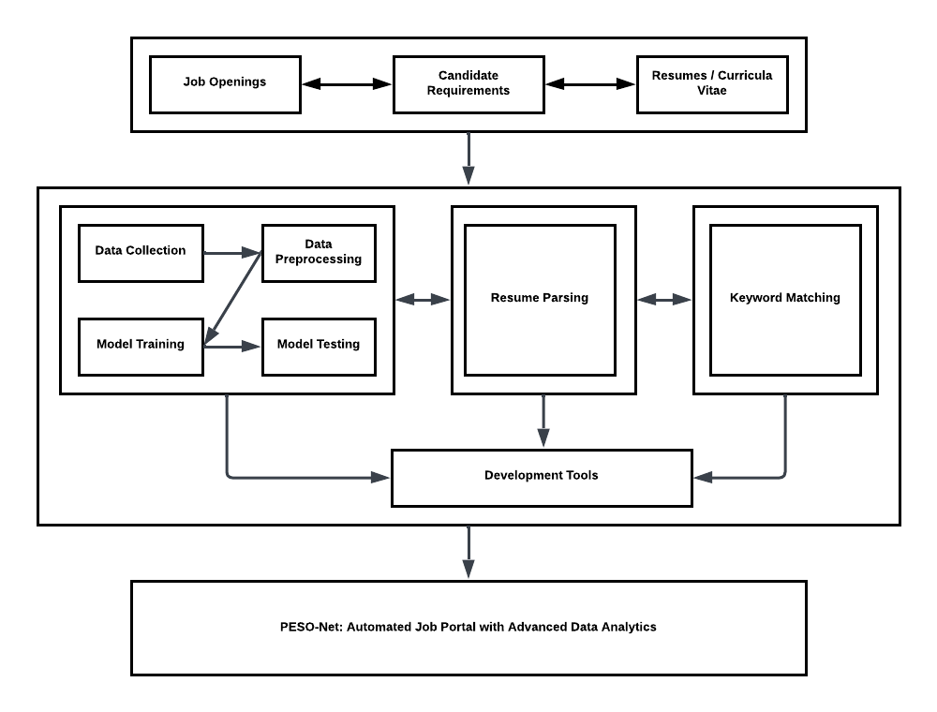

Figure 2. 1

Conceptual Framework of the Study

The proposed system's conceptual framework is presented in Figure 2.1. The framework is structured into three main containers, namely inputs, processes, and outputs, which provide a comprehensive description of the relevant concepts, ideas, and relationships involved in the study. The inputs include job openings, candidate requirements, and resumes/curricula vitae of job seekers. The processes consist of data collection, data preprocessing, model training, and model testing, which are used to generate criteria for job and applicant recommendations. Additionally, resume parsing is employed to extract data for comparison. Lastly, keyword matching is used to compare the extracted data with the collected, preprocessed, trained, and tested data. The output is the PESO-Net System, an automated job portal equipped with advanced data analytics.

**CHAPTER III**

# **DESIGN AND METHODOLOGY**

## **Software Development Model**

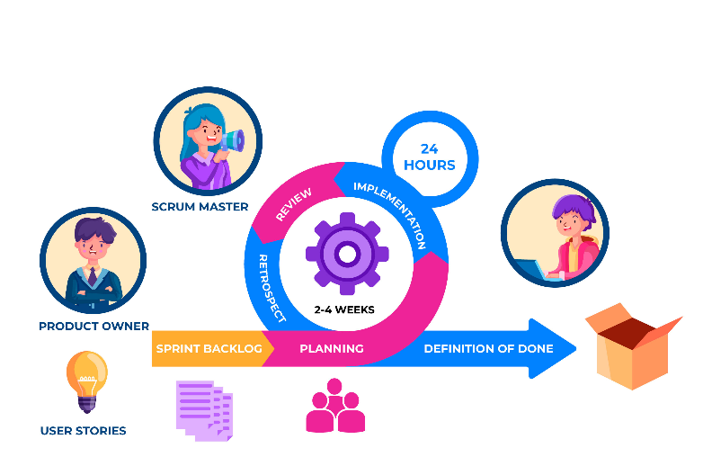

Figure 3. 1

Scrum methodology for the Proposed System.

To develop the PESO-Net in Lipa City, an Agile Development approach with Scrum as the specific methodology will be implemented, as depicted in Figure 3.1. This approach involves multiple phases that are essential for analyzing and designing the system, resulting in process improvements that enable the achievement of goals. The goal is to enhance the efficiency, streamline the process, and improve reliability of the job recruitment process.

Moreover, the proponents believed that the utilization of Scrum is the most suitable approach for the development process of this study. An automated job acquisition system project may involve a number of different stakeholders, such as PESO Staff, job seekers, and head of PESO, and could involve a variety of technical challenges related to data processing, user authentication, and system integration. Scrum can help manage these challenges by providing a framework for effective collaboration and communication between team members and stakeholders, as well as a structured process for managing project priorities, risks, and scope. Given that, the proponents of this study will present the various phases, along with their respective sub-processes, which they will employ throughout the study.

1. **Product Backlog:**

The proponents maintain a Product Backlog, which serves as the central repository of features, functionalities, and enhancements for the automated job portal. It contains user stories, prioritized based on their importance and value. The backlog is continuously refined and updated throughout the project, incorporating feedback from stakeholders and the client.

1. **Sprint Planning:**

During the sprint planning sessions, the proponents, together with the development team, client, and relevant stakeholders, select a set of user stories from the Product Backlog to be developed and delivered in the upcoming sprint. The scope, objectives, and expected outcomes of the sprint are defined, ensuring a clear direction for the development efforts.

1. **Sprint Execution:**

The development team, led by the proponents, works collaboratively during the sprint to implement the selected user stories. They follow the Agile principles and Scrum framework, organizing their work in short time-boxed iterations known as sprints, typically ranging from one to four weeks. Daily stand-up meetings are conducted to provide updates on progress, address challenges, and ensure effective communication within the team.

1. **Sprint Review:**

At the end of each sprint, the proponents arrange a sprint review session to showcase the completed work to the client and stakeholders. The development team demonstrates the implemented features, functionalities, and enhancements, seeking feedback and validation. This review session helps gather valuable insights, identify areas of improvement, and make necessary adjustments to the project's direction.

1. **Sprint Retrospective:**

Following the sprint review, the proponents facilitate a sprint retrospective meeting. The development team reflects on the completed sprint, discussing what went well, what could be improved, and potential actions to enhance future sprints. The retrospective encourages continuous learning, adaptation, and the implementation of process improvements to optimize the team's productivity and effectiveness.

1. **Deployment:**

Once a sufficient number of sprints are completed and approved, the proponents oversee the deployment phase. The automated job portal is prepared for production release, ensuring necessary testing, quality assurance, and integration with relevant systems or platforms. The deployment process includes proper documentation, training for users, and a smooth transition to the operational environment.

## **Fishbone Analysis**

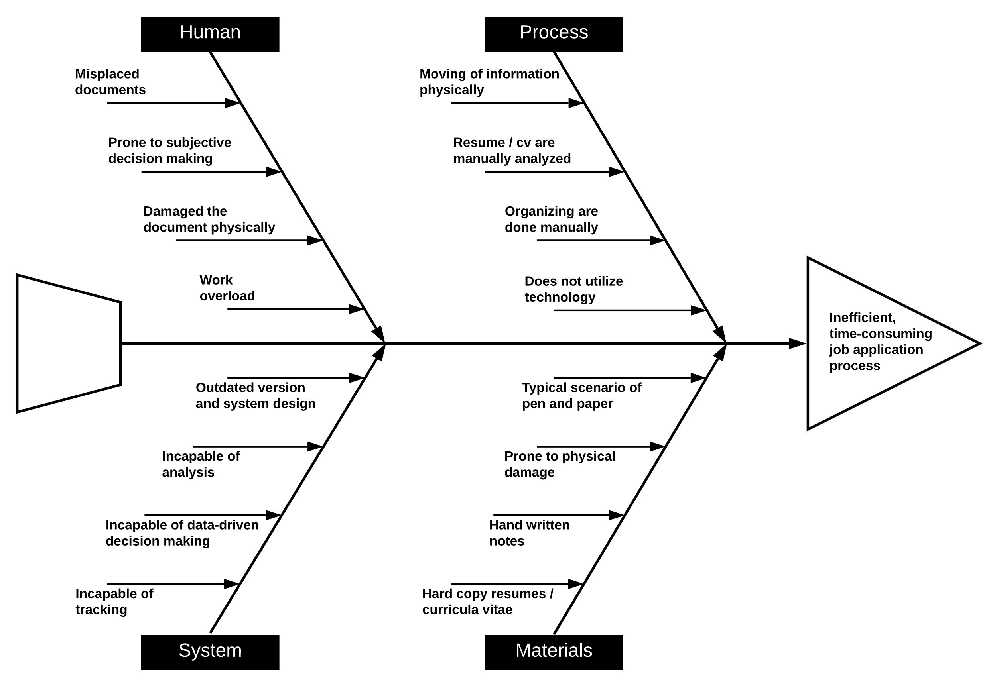

Figure 3. 2

Fishbone Diagram.

The presented fishbone diagram, Figure 3.2, is the result of a brainstorming session conducted by the proponents that identified and categorized a range of possible causes of problems or issues. They assessed the validity of each bone by analyzing data and reaching a consensus on which causes are probable. The analysis resulted in the identification of four causes in the recruitment process Human, System, Process, and Materials, and their respective effects. The human factor was found to be the likely cause of the problem, with work overload leading to inefficiencies in handling job applications. The manual processes were also identified as root causes throughout the recruitment process.

## **System Boundary**

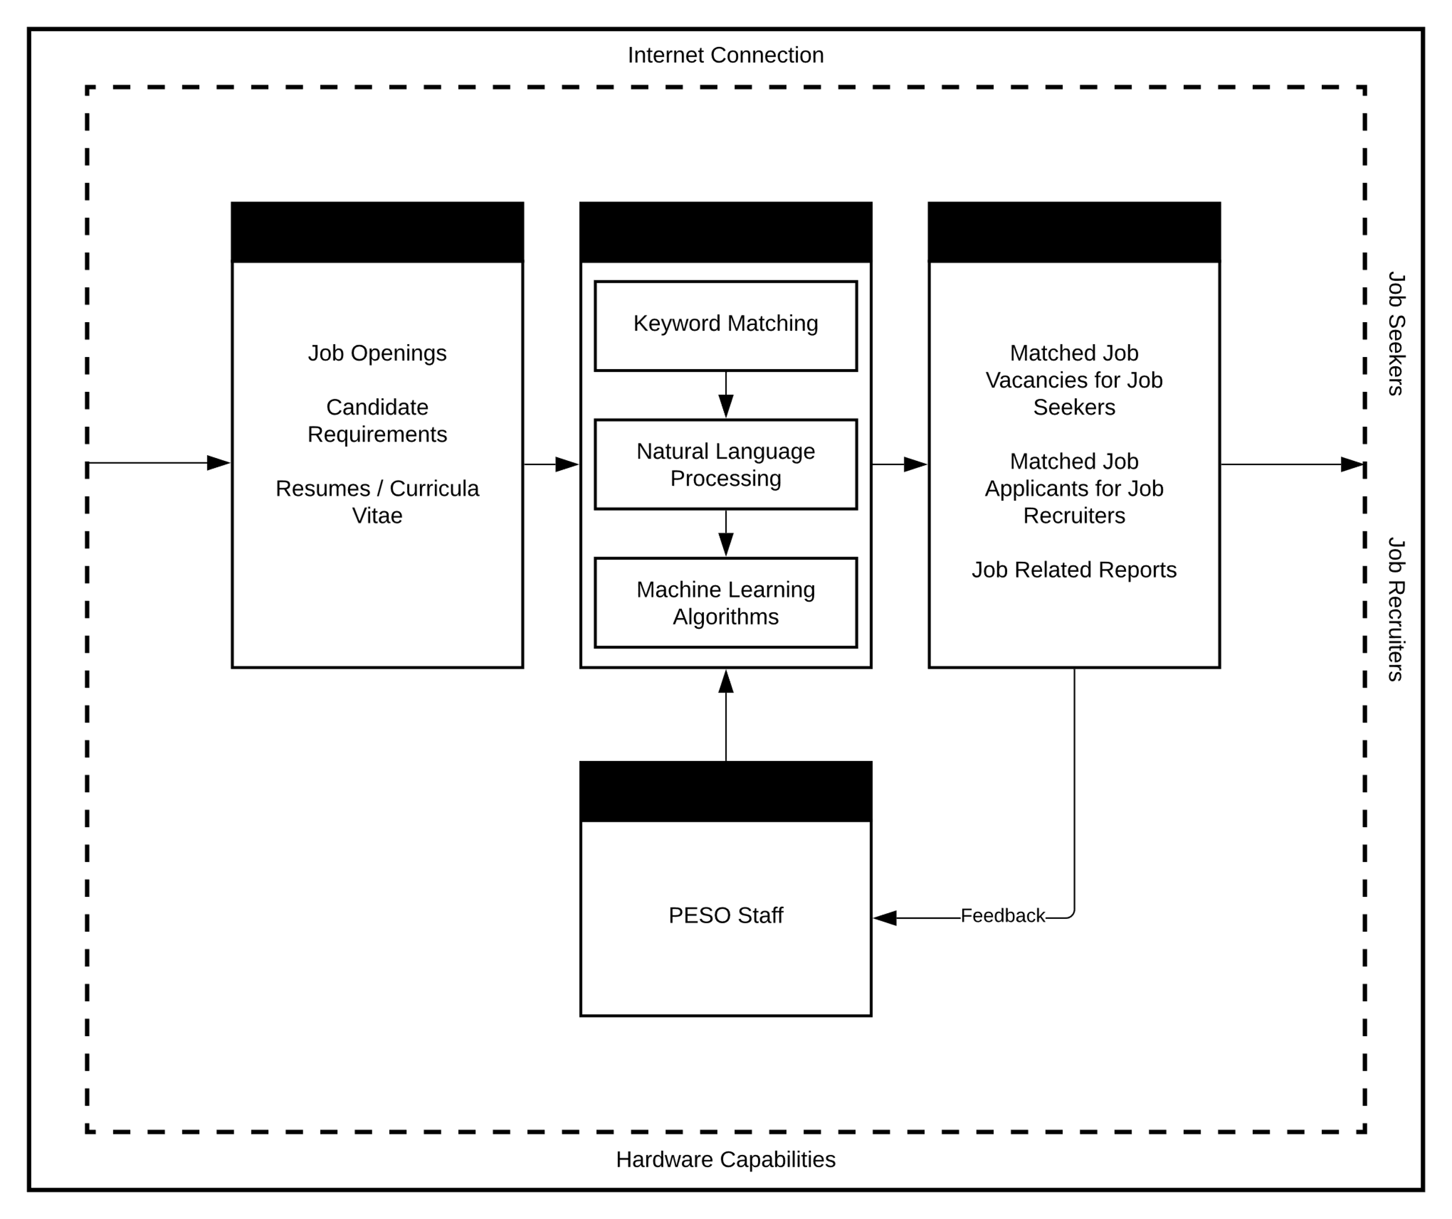

Figure 3. 3

System Boundary of the proposed system

In systems design, it is essential to identify and establish the system's components and what is outside in the environment. This process is known as defining the system boundary, and it plays a central role in ensuring that the system functions efficiently and effectively. The proponents of the automated job acquisition system identified the system boundary as illustrated in Figure 4, where the dashed line serves as a boundary that separates the internal components and entities of the system from the external entities or environment. Among the identified external entities are the job seekers and job recruiters, who provide inputs and consume outputs of the system.

Since the automated job acquisition system is designed for real-life job recruitment processes, the proponents ensured that the system can function efficiently in various potential difficulties and challenges. This includes considering external factors that affect the system's performance, such as internet connection and hardware capabilities. The proponents acknowledged the importance of the system's environment and regarded that what happens outside the system is of vital importance. By identifying and understanding the external entities, the proponents can create a system that is adaptable to the needs of its users and the external factors that may affect its performance.

## **Hardware Requirements**

Shown in Table 3.1. is the hardware requirements that are intended to determine appropriate hardware components that will support the efficient and effective functioning of PESO-Net. To achieve this goal, the proponents have identified several critical hardware components that are necessary for the successful implementation of PESO-Net, including the storage devices, processor, memory, input, and output devices. The processor requirements necessitate an Intel Core i5 or AMD Ryzen 5 processor or equivalent for optimal efficacy. Furthermore, the hard disk drives minimum capacity should be 500 GB, with a 256 GB SSD being the recommended storage device. Similarly, the memory requirements dictate a minimum of 8 GB or higher RAM to improve performance.

|  |  |  |
| --- | --- | --- |
| **Hardware** | **Minimum Requirements** | **Recommendation** |
| Processor | Processor | Processor |
| Intel Core i5/ AMD Ryzen 5 | Intel Core i5/ AMD Ryzen 5 | Intel Core i5/ AMD Ryzen 5 |
| Intel Core i5/ AMD Ryzen 5 and above | Intel Core i5/ AMD Ryzen 5 and above | Intel Core i5/ AMD Ryzen 5 and above |
| Memory | Memory | Memory |

Table 3. 1.

Hardware Requirements

In addition, a variety of input devices, such as a keyboard and mouse, as well as output devices, like monitors, are required for the PESO-Net automated job portal in order to facilitate system operations. Printers are another crucial component because the system is built to generate reports about job-related information. The PESO-Net system will be able to provide cutting-edge data analytics and automated recruitment services to the public service office in Lipa City, Batangas, with these hardware requirements in place.

## **Software Requirements Specification**

For the purpose of designing and implementing PESO-Net, the functional and non-functional requirements are thoroughly described in the software requirements specifications. It will serve as an outline for the development team, as the developers will build a system that satisfies the requirements of PESO Lipa and its stakeholders. The system’s capabilities, its interfaces with other systems, the hardware and software requirements, as well as the performance and security requirements, are all elaborately described in this section. It also describes the procedures for testing and validating the system to make sure it complies with the standards.

## **Software Requirements**

To meet the needs of the system, software requirements are categorized into specification and type categories in addition to hardware requirements, as shown in Table 3.2. Among the software needs are the operating system, web browser, database, and software tools.

|  |  |  |
| --- | --- | --- |
| **Software** | **Minimum Requirements** | **Recommendation** |
| Operating System | Operating System | Operating System |
| Windows 10/ Linux CentOS 7/ Ubuntu 18.04 | Windows 10/ Linux CentOS 7/ Ubuntu 18.04 | Windows 10/ Linux CentOS 7/ Ubuntu 18.04 |
| Windows 10/ Linux CentOS 7/ Ubuntu 18.04 and above | Windows 10/ Linux CentOS 7/ Ubuntu 18.04 and above | Windows 10/ Linux CentOS 7/ Ubuntu 18.04 and above |
| Web Browser | Web Browser | Web Browser |

Table 3. 2.

Software Requirements

Windows 10 or later or Linux distributions like CentOS 7 or later or Ubuntu 18.04 or later must be used as the operating system. The most recent versions of well-known web browsers, including Google Chrome, Mozilla Firefox, and Microsoft Edge, can be used to access the web portal. Additionally, the backend database management system for the PESO-Net system must be PostgreSQL. Processes for storing and retrieving data will be easy and effective as a result. Lastly, the software tools utilized in building the PESO-Net system are HTML, CSS, JavaScript, and Python.

## **Functional Requirements**

This section entailed the functional requirements that define the tasks and action that the system will accomplish and execute. In other words, it provides a description of the services and functions that the system supported. The capabilities determined during the planning phase served as the direct basis for the functional needs.

1. **Job Seeker**
   1. The system shall allow job seekers to create an account and log in securely.
   2. The system shall enable job seekers to search for job vacancies based on their specified criteria.
   3. The system shall provide job seekers the list of job vacancies available based on their search criteria.
   4. The system shall enable users to apply for job vacancies through the platform.
   5. The system shall notify job seekers if they fit the job criteria based on their resume / curriculum vitae.
   6. The system shall notify job seekers of any updates or changes in their job application status.
2. **PESO staff**
   1. The system shall allow PESO staff to post job vacancies in the platform requested by the partnered companies.
   2. The system shall allow PESO staff to manage posts on the platform.
3. **Job Recruiter**
   1. The system shall allow job seekers to send job postings in the system which will be validated by the PESO staff.
   2. The system shall notify recruiters if the system found suitable candidates based on their job description.
4. **System**
   1. The system shall maintain a record of all job vacancies and applications received for future reference and analysis.
   2. The system shall ensure the confidentiality of all records by implementing secure authentication and access control mechanisms.
   3. The system shall impose measures to prevent spamming cv / resume.

## **Non-Functional Requirements**

A non-functional requirement is one that describes criteria rather than specific behaviors that can be used to evaluate how a system performs. The system also considered other non-functional requirements to test its capability to satisfy the users' needs.

1. **Performance**
   1. The job portal should be able to handle a large volume of concurrent users.
   2. The job portal should provide fast load times and response times.
   3. The system's operations always operate as intended and every page of the system loads exactly as it was designed.
2. **Reliability**
   1. The job portal should be highly reliable and available.
   2. The job portal must have minimal downtime and data loss.
3. **Scalability**
   1. The job portal should be designed to accommodate future growth and expansion.
   2. The job portal should be able to handle increasing amounts of job listings, applicants, and data.
4. **Security**
   1. The job portal should be designed with strong security features to protect user data, prevent unauthorized access, and maintain compliance with data privacy regulations.
   2. The system must have features such as authentication, encryption, and access controls.
5. **Usability**
   1. The job portal should be designed for both job seekers and PESO personnel intuitive and simple to use.
   2. The system must be user-friendly and accessible anywhere with an internet connection.
   3. The system design must be so appealing and so enjoyable to use that it is not a sore in the eyes of the users.
6. **Compatibility**
   1. The job portal should be compatible with a wide range of web browsers, devices, and operating systems.
   2. The system must be responsive and can be used with different devices and browsers other than the one which it was created without requiring rework.
7. **Maintainability**
   1. The job portal should be developed with clear, well documented architecture and code, making it simple to maintain and improve over time.
   2. The system must be simple to fix when flaws and errors arise, and if issues do arise, they may be resolved within the allotted time frame

## **Constraints**

The tables below cover the software design constraints, and the ratings were based on an independent and thorough evaluation of each option. The proponents’ familiarity and background knowledge were taken into account during the evaluation.

|  |  |  |  |
| --- | --- | --- | --- |
| **Parameter** | **Angular** | **React** | **Vue** |
| Performance | 7 | 9 | 8 |
| Flexibility | 8 | 8 | 8 |
| Ease of Use | 6 | 7 | 9 |
| Community Support | 8 | 9 | 7 |
| Scalability | 7 | 9 | 8 |
| Testing and Debugging Tools | 7 | 9 | 8 |
| Compatibility | 8 | 9 | 9 |

Table 3. 3.

***Front-end Development Tools***

After careful consideration of various front-end development tools, the proponents have narrowed down their options to three namely Angular, React, and Vue, as presented in Table 3.3. Based on their familiarity and expertise, the proponents have ultimately decided to use React as their primary front-end development tool for creating dynamic and interactive user interfaces. With its robust capabilities and extensive support from the community, react is well-suited for building complex UIs with ease and efficiency.

|  |  |  |  |
| --- | --- | --- | --- |
| **Parameter** | **PHP** | **Python** | **Ruby** |
| Performance | 7 | 8 | 7 |
| Security | 6 | 8 | 8 |
| Flexibility | 8 | 9 | 9 |
| Ease of Use | 8 | 9 | 8 |
| Community Support | 9 | 10 | 8 |
| Scalability | 7 | 9 | 8 |
| Testing and Debugging Tools | 6 | 9 | 9 |
| Compatibility | 9 | 9 | 9 |

Table 3. 4.

***Server-side Scripting Language***

Table 3.4. shows the conducted thorough evaluation of PHP, Python, and Ruby, taking into account key factors. Few of these include performance, security, flexibility, and community support. After careful consideration, the proponents concluded that Python was the most suitable choice for the system due to its excellent performance and security, as well as its flexibility and ease of use. Additionally, Python's strength in data analytics was a key consideration given that it is a critical component of the system. As a result, the proponents decided to utilize Python as their server-side scripting language, confident that it would provide the necessary functionality and performance for the automated job acquisition system.

|  |  |  |  |
| --- | --- | --- | --- |
| **Parameter** | **MySQL** | **PostgreSQL** | **MongoDB** |
| Performance | 8 | 9 | 7 |
| Security | 7 | 8 | 7 |
| Ease of Use | 9 | 7 | 8 |
| Community Support | 10 | 9 | 8 |
| Scalability | 9 | 9 | 9 |
| Speed | 9 | 8 | 8 |
| Reliability | 9 | 9 | 8 |

Table 3. 5.

***Database Management Tools***

Shown in Table 3.5. is a thorough evaluation of MySQL, PostgreSQL, and MongoDB, considering multiple parameters such as performance, security, ease of use, community support, scalability, speed, and reliability. While MySQL scored high in terms of speed and ease of use, PostgreSQL emerged as the best choice due to its support for advanced data types, indexing, and query optimization. Additionally, PostgreSQL has a strong reputation for reliability and is known for its scalability, making it the preferred choice for the proponents despite high favorability towards MySQL. Overall, the evaluation was conducted with the end-users' requirements in mind, ensuring that the chosen database management tool is capable of handling the system's advanced data analytics and machine learning capabilities.

|  |  |  |  |
| --- | --- | --- | --- |
| **Parameter** | **VisualStudio Code** | **Sublime Text** | **Atom** |
| User Interface | 8 | 7 | 8 |
| Code Editing Features | 9 | 8 | 8 |
| Language Support | 9 | 8 | 8 |
| Third-Party Plugins Support | 10 | 9 | 10 |
| Performance | 9 | 9 | 7 |
| Familiarity | 8 | 6 | 5 |

Table 3. 6.

***Text Editor***

Depicted in Table 3.6 are the distinctive text editors for web development such as VisualStudio Code, Sublime Text, and Atom. Upon careful evaluation of the said text editors, the proponents unanimously agreed to use VS Code mainly because of the familiarity of the proponents, as well as its robust features and extensive support for third-party plugins like Live Share, Go Live, Prettier, and others. While Atom and Sublime Text are both lightweight IDE software, the proponents found them lacking in comparison to VS Code in terms of features and plugin support. Thus, VS Code is the preferred text editor for this project.

## **Multiple Designs**

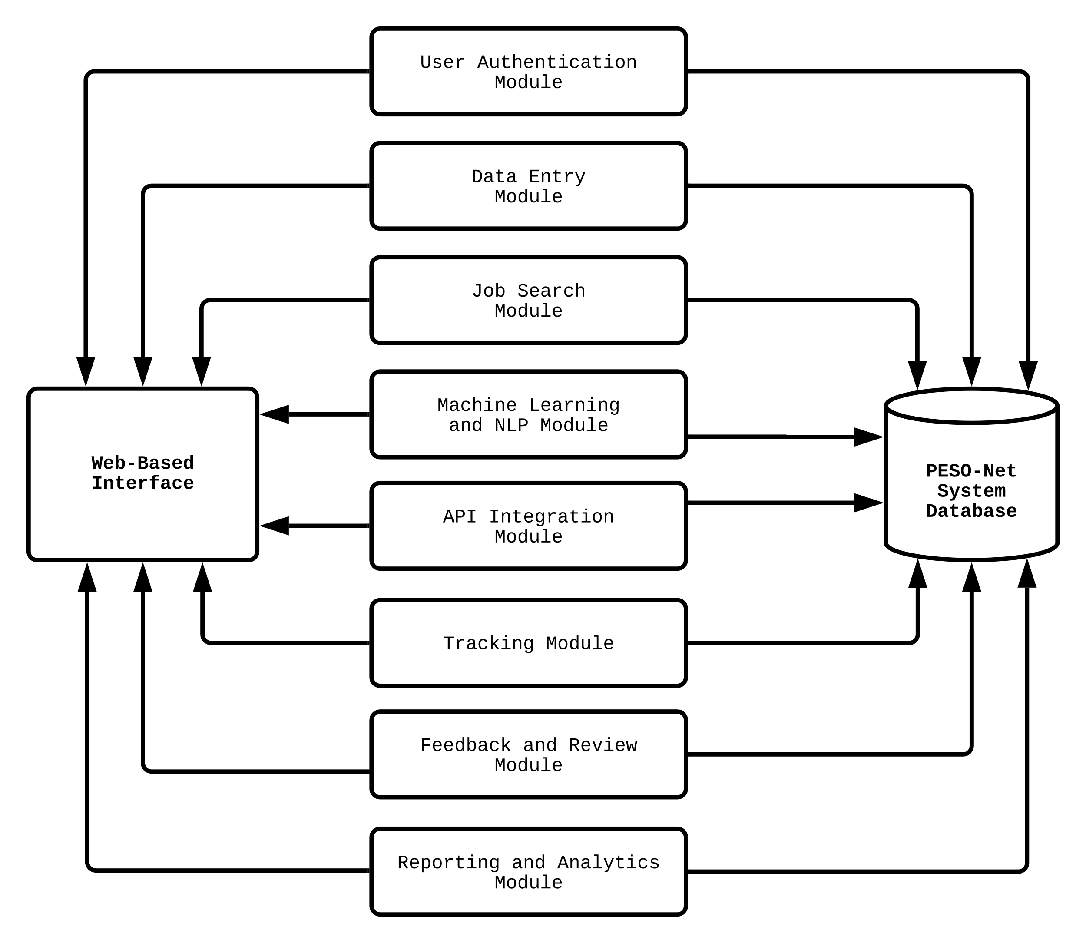

Figure 3. 4.

System Modules of the proposed system.

The PESO-Net comprises database-driven modules designed to store, present, and generate reports as well as documents needed by the identified users such as the Job Seekers, Staff, and Job Recruiters. In order to support each user type, eight system modules will be created for the PESO-Net system and these are presented through a Block Diagram in Figure 3.4.

As observed in the block diagram, the accreditation system has fourteen modules. Each module is created and designed according to the functions described below:

1. *User Authentication Module:* This module is responsible for authenticating users and authorizing them their grants based on their roles in the system.
2. *Data Entry Module:* This module is responsible for data entries to be done in the system whereas the Create, Read, Update, and Delete (CRUD) functions are applied.
3. *Job Search Module:* This module is used by the job seekers in searching for available jobs uploaded in the system.
4. *Machine Learning and NLP Module:* This module is used for analyzing, extracting, and providing insights from the inputted files by the job seekers. It can also be used for analyzing job postings by the job recruiters.
5. *API Integration Module:* This module will be responsible for allowing the system to communicate and interact with third-party applications by enabling data exchange between them. It provides a seamless integration between the system and other services, enhancing its functionality and user experience.
6. *Tracking Module:* In this module, the PESO staff / job recruiters will provide updates to the job seekers through this module.
7. *Feedback and Review Module:* This module will contain the feedback from the users which will be used to analyze and improve the system.
8. *Reporting and Analytics Module:* This module is used primarily whenever a user requests a report of their records. Moreover, the report is available in MS Excel and PDF formats, and can also be printed.

## **Security**

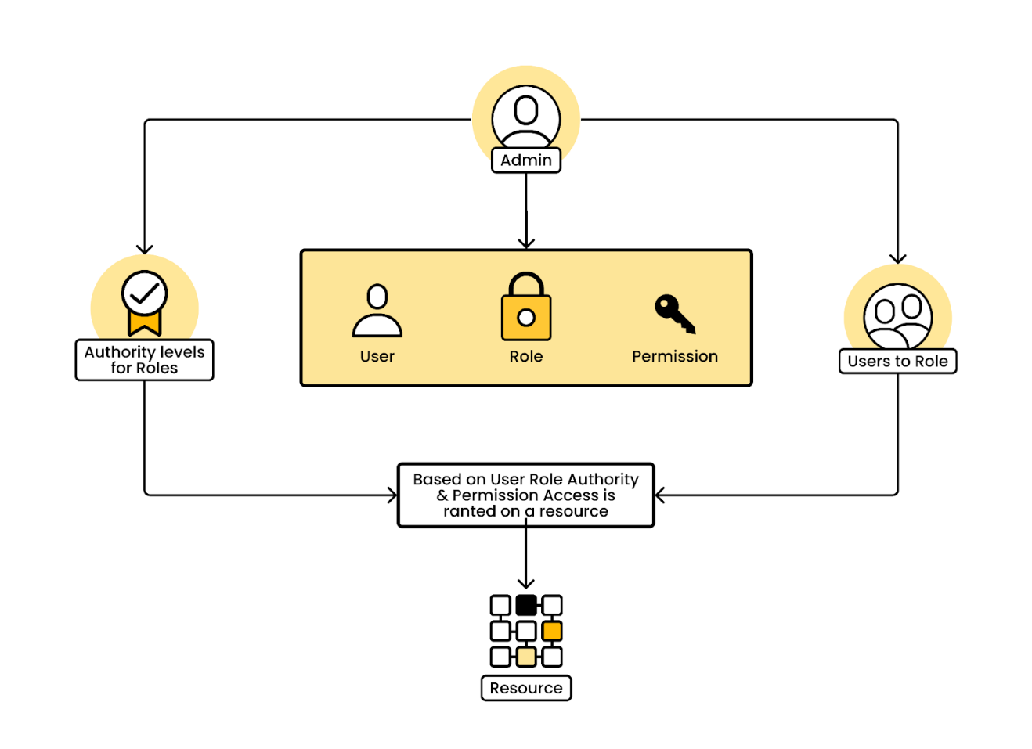

Figure 3. 5.

Role-Based Access Control Model for the

proposed system’s security.

The PESO-Net system is designed with security as a crucial factor to ensure the protection of its users' data. To achieve this, the system incorporates specific methods for authentication and authorization based on the Role-based access control (RBAC) Model. The RBAC Model is a security architecture that comprises roles, permissions, operations, and objects. These components work together to grant users access to specific areas of the system based on their assigned roles and permissions.

The RBAC Model is an effective approach to managing access control in software systems. In the PESO-Net system, it ensures that only authorized users can access sensitive information and perform specific operations. For example, the User Authentication Module is responsible for authenticating users and granting them access based on their assigned roles. This ensures that only users with the appropriate credentials can access sensitive areas of the system. Furthermore, the RBAC Model provides a flexible and scalable approach to access control. It allows for the creation of custom roles with specific permissions to match the needs of different users. For example, the Tracking Module in the PESO-Net system can be restricted to PESO staff and job recruiters only, while the Feedback and Review Module can be made accessible to all users. This level of customization ensures that the system remains secure while still meeting the needs of its users.

In conclusion, the incorporation of the RBAC Model in the design of the PESO-Net system is a crucial step in ensuring the security of the system and its users' data. It provides a flexible and scalable approach to access control, ensuring that only authorized users can access sensitive information and perform specific operations.

## **Tradeoffs**

The study’s focus is narrowed to the examination of hiring practices and systems for public employment service office jobs in Lipa City, Batangas, which is a drawback because it leaves out other aspects of the labor market, like job training and career development. This raises a potential issue when implementing the project's recommendations in other job markets. Another, the findings of the study may not be applicable to all systems or employment markets. Therefore, it might need additional testing and validation before being implemented in other settings.

Additionally, the reliability of the study’s findings may be impacted by the quantity and quality of data sources. The quality and completeness of the data available may have an impact on the project’s suggestions, which may restrict how widely it can be applied. Lastly, the creation of an automated job acquisition system also requires a large investment of time and resources. Therefore, the project might not cover all options for ensuring effectiveness necessitating further study.

## **System Design / Architecture**

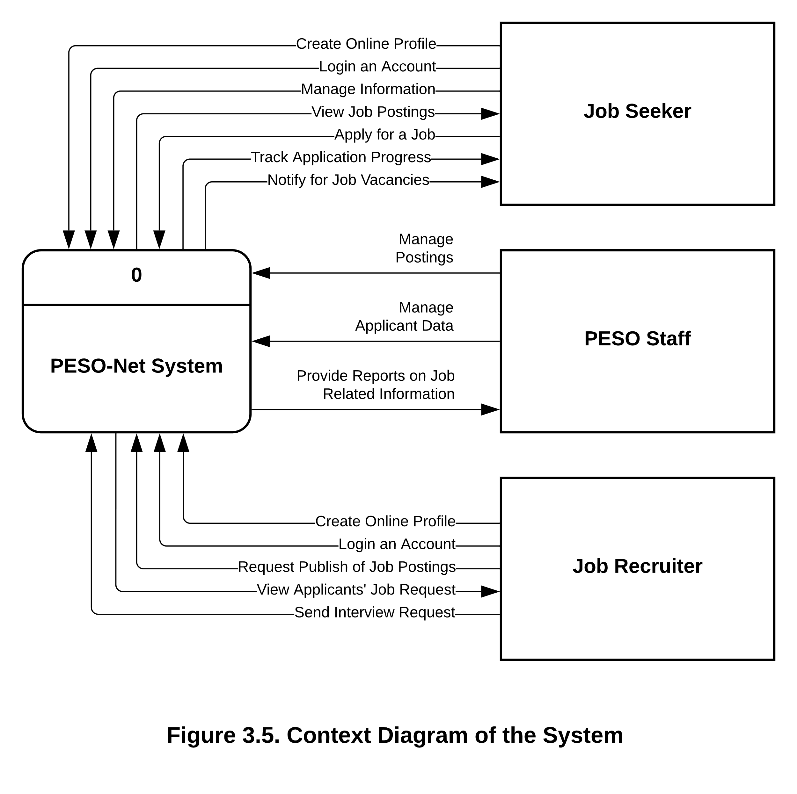

Figure 3. 6.

Context Diagram of the proposed system.

Figure 3.6 is a graphical representation of the information flow in the PESO-Net system. It shows the different processes involved in capturing, manipulating, storing, and distributing data between the system and its environment, as well as between its components. The system is considered a single high-level process, as shown in the context diagram. Additionally, the diagram illustrates the relationships between the system and other entities such as Job Seekers, Job Recruiters, and PESO staff.

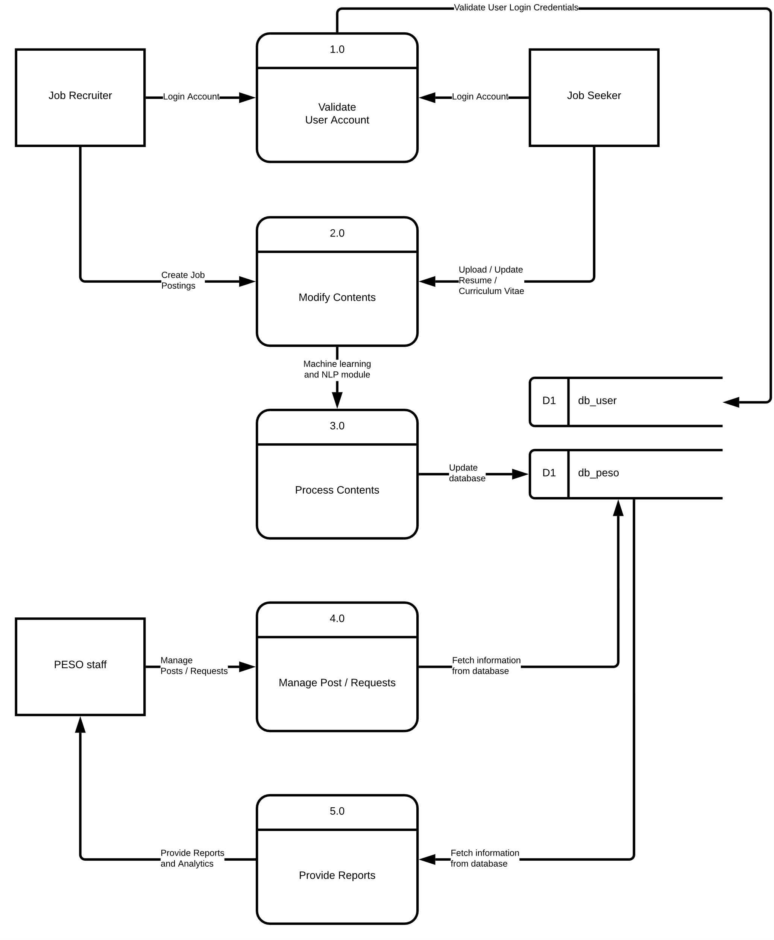

Figure 3. 7.

Data Flow Diagram Level 0.

Figure 3.7 shows a more in-depth explanation of how the system will work which is presented in a Level-0 diagram. Process 0 was broken down into 5 major processes involved in the project, validating accounts, modifying contents, processing contents, managing posts / requests, and providing reports.

As shown in the figure, the user gets validated first before the system grants them ability to do modifications. The user will only have the ability to do modification if user is logged in, if not, it will only have basic rights into the system like viewing. After the job recruiter / job seeker input, it will then be processed using machine learning and natural language processing for the analysis and extraction of the valuable information either job posting or resume / curriculum vitae. After that, it will be saved to the database specifically created for the job postings and the extracted information for resume / curriculum vitae. The job postings would then be validated by the PESO staff in their dashboard. The job recruiter can also manage posts and manage users that applied to their job posting or highly suitable for the position that is recommended by the system.

## **Link Architecture**

Figure 3. 8.

Link Architecture of the proposed system.

The diagram in Figure 3.8 illustrates the link architecture, which presents the functions of various users, including PESO staff, Job Seekers, and Job Recruiters. It will serve as a foundation for constructing the system's flow.

## **Use Case**

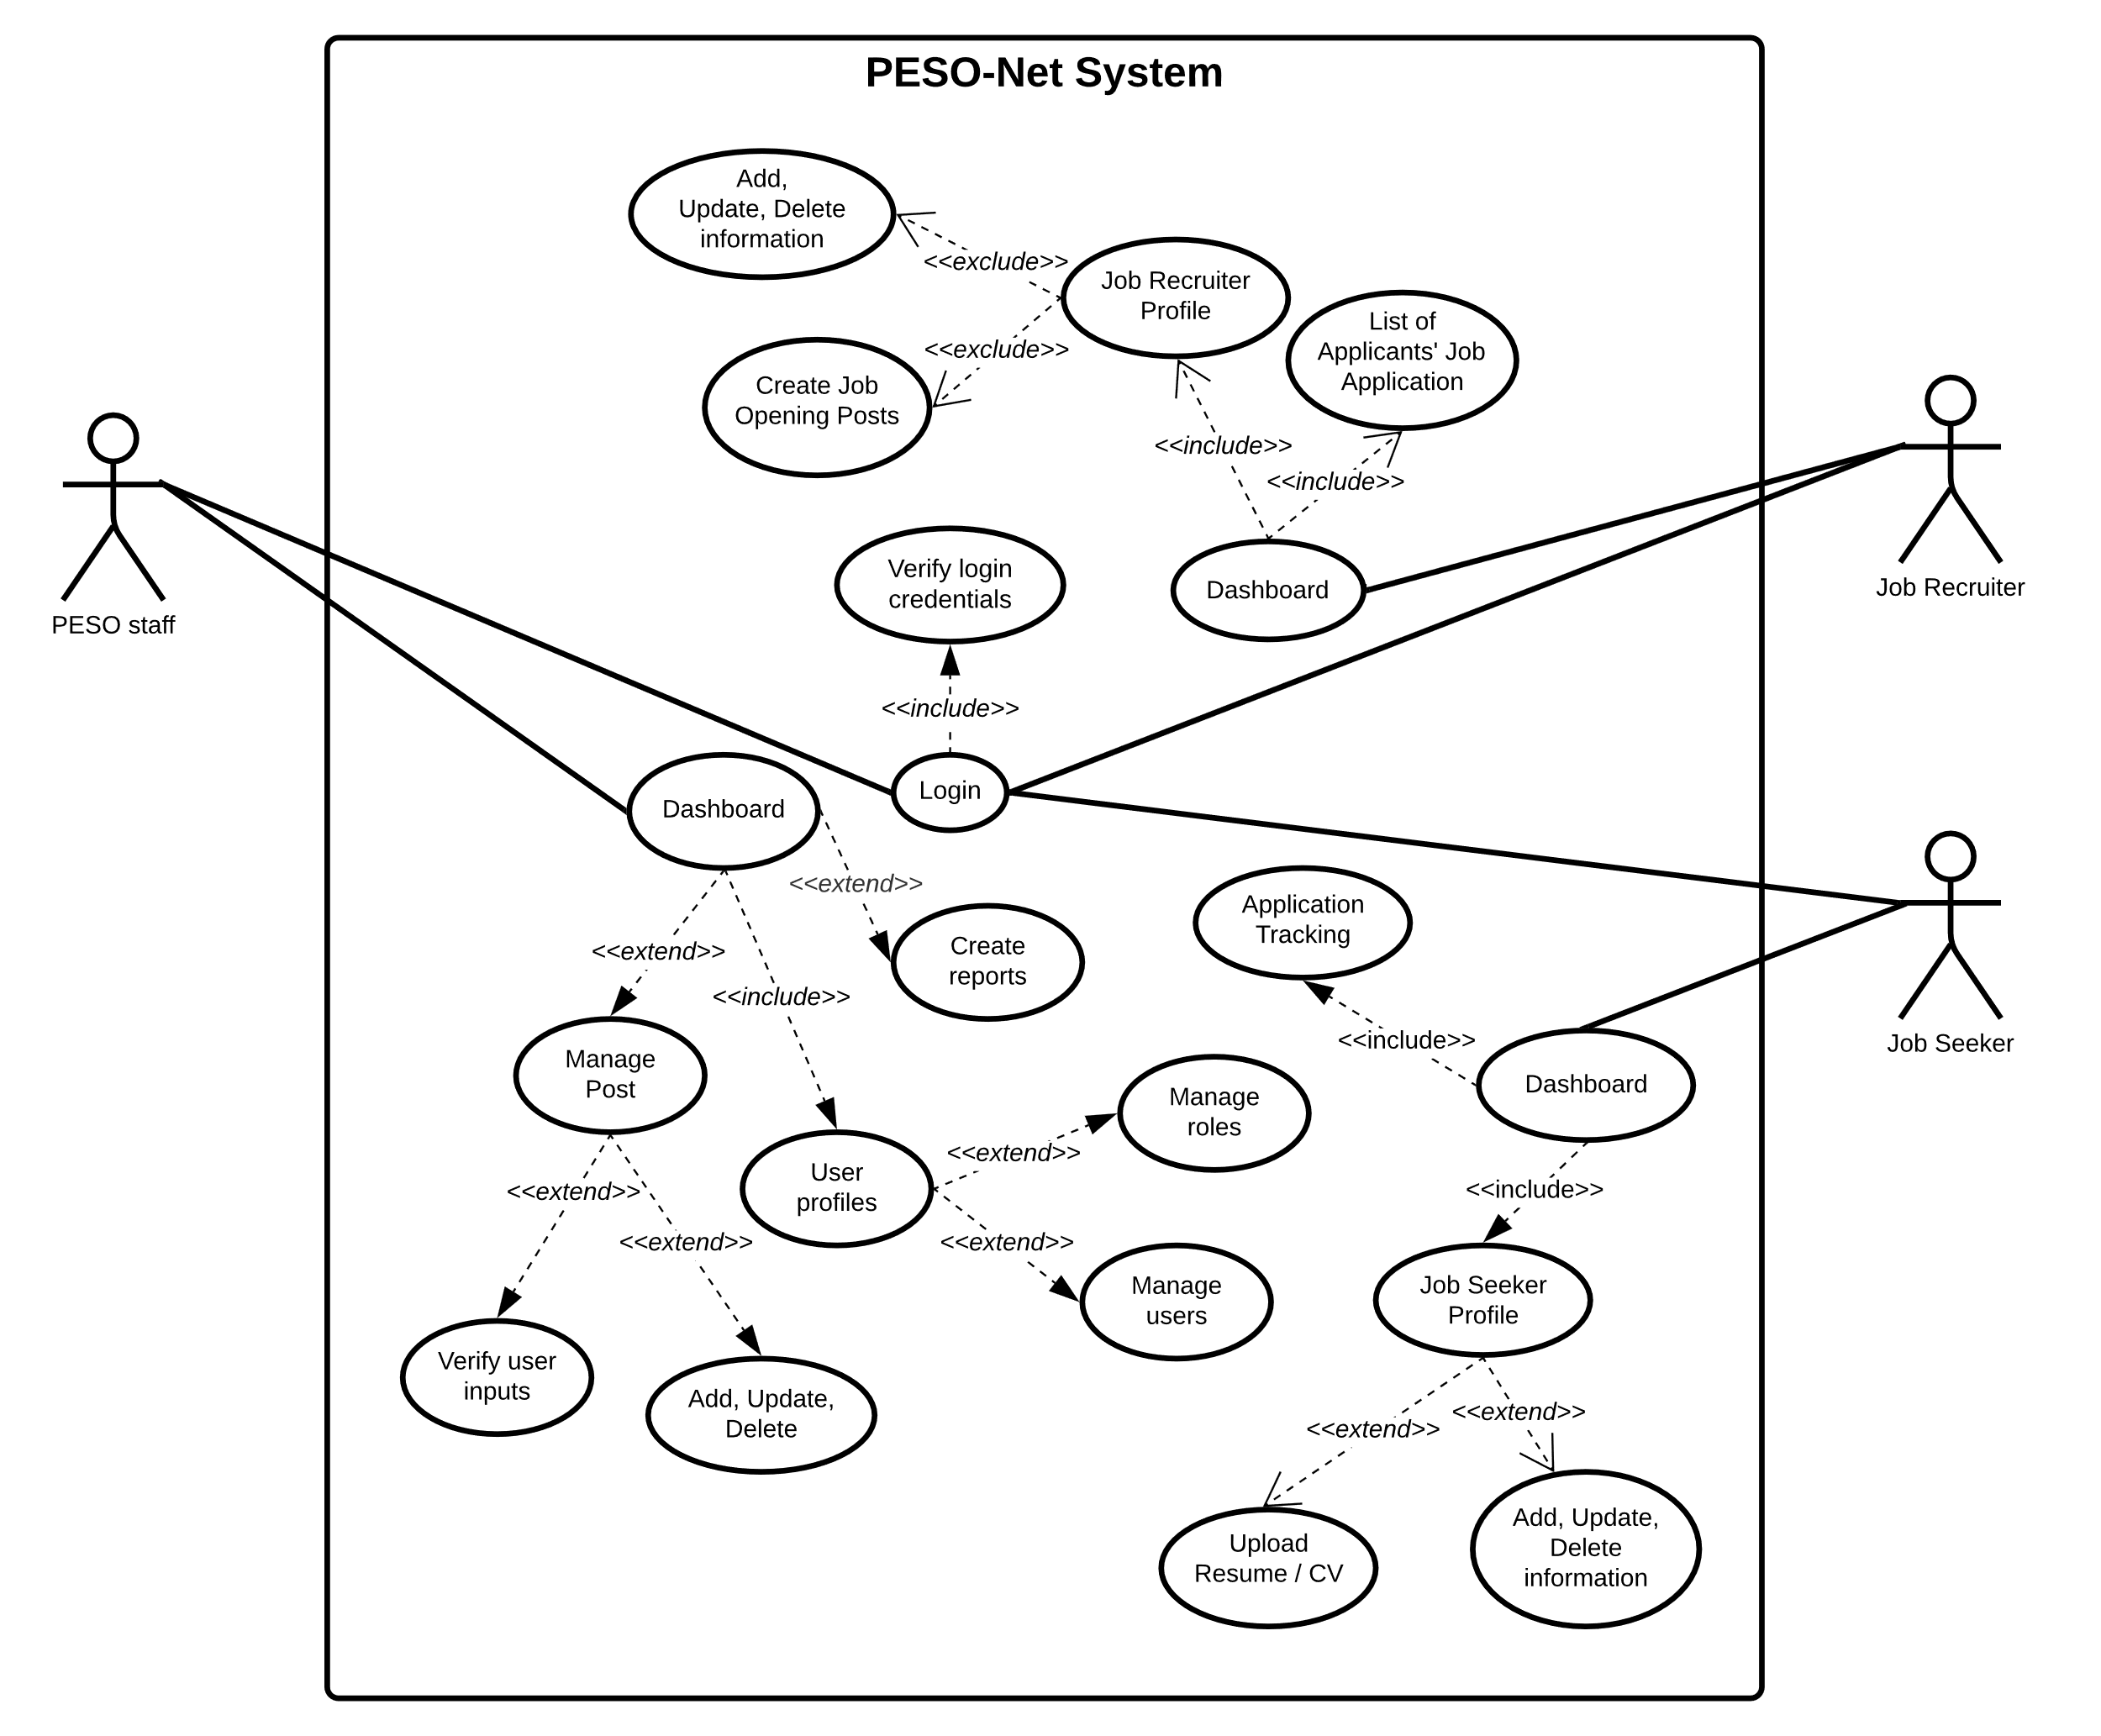

Figure 3. 9.

Use Case of the Proposed System.

The Use Case diagram presented in Figure 3.9 provides a visual representation of the different types of users and their respective interactions with the PESO-Net system. It illustrates how each user can utilize the system through the use of specific actions or use cases, allowing for a clear understanding of their relationship with the system.

The diagram shows that PESO staff is the main actor in the system, possessing full authorization to manage posts and users. Job recruiters have limited access compared to PESO staff. On the other hand, job seekers have a dashboard that enables them to modify their profile, upload files, and track their application status. Job recruiters, meanwhile, have a dashboard that allows them to view a list of applicants, modify their profile, and create job postings. The list of applicants that recruiters can view includes both direct applicants to their job postings and those who show great compatibility with their job postings. Overall, the Use Case diagram provides a comprehensive view of the system's functionalities and the roles of its users.

## **Sequence Diagram**

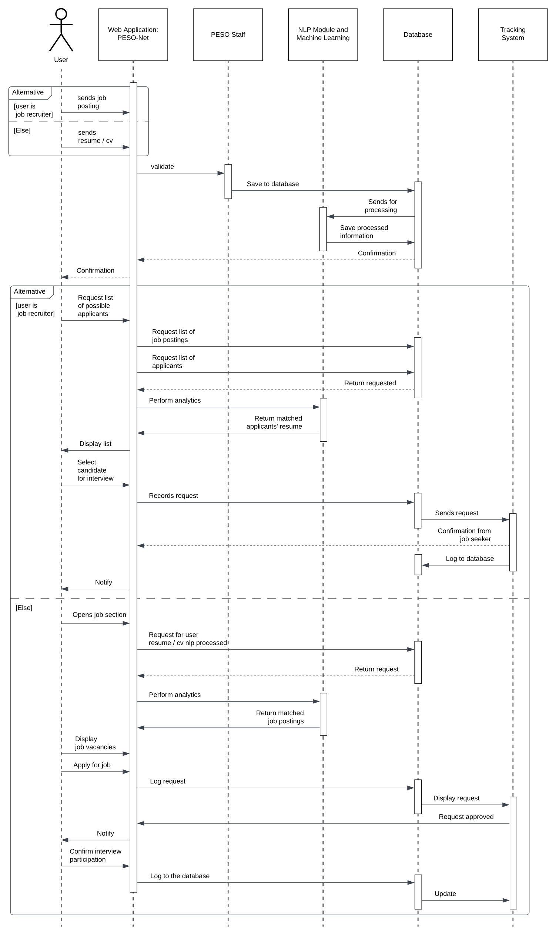

Figure 3. 10.

Sequence Diagram of the Proposed System.

Illustrated in Figure 3.10 is a sequence diagram that details how operations in the PESO-Net system would be carried out, what messages are sent and when. Based on the diagram, the sequences were organized according to time which progresses as a user login to the page.

In this sequence diagram, the main actor is represented as an object to signify that their role is to facilitate the flow of information rather than directly inputting anything into the system. The actor is named "user" to generalize both the job seeker and job recruiter, as the proponents observed that these two roles are very similar with only minor differences. To differentiate between them, the diagram uses an alternative symbol to categorize job seekers from job recruiters. The PESO staff is also included in the sequence diagram and declared as an object named "PESO staff". This is because they play a crucial role in facilitating the flow of information within the system. By including them in the diagram, it provides a more detailed and accurate representation of the process, as they are an integral part of the system and their actions impact the overall flow of information.

Overall, the use of objects and generalization in the sequence diagram allows for a more concise and organized representation of the system's functionality. It also highlights the importance of the various actors in the process and their unique roles in facilitating the flow of information.

## **Database Design**

Figure 3. 11.

Database Design of the proposed system.

Shown in Figure 3.11. is the illustration of database design that the proponents come up with after a careful investigation of included entities in the system. The database would include tables for user information, user account, job seeker, job recruiter, resume, criteria, job postings, and application status.

To ensure proper organization and easy access to user information, the system will have a user information table that will include all the necessary information such as name, address, contact number, and role. The role of each user will determine their level of access within the system, and it will be set upon registration.

Since job seekers and job recruiters have different profile information, separate tables were created for them. The job recruiter profile table will include information such as company name, location, and website, while the job seeker profile table will include information such as email, skills, and certifications. It's worth noting that the skills, education, and certifications in the job seeker table will not be inputted manually but will instead be analyzed and extracted from their uploaded resume or CV, which is saved in the resume table.

Another important table in the system is the job posting table, which will contain all job postings created by job seekers. These postings will be verified and approved by the PESO staff before being published on the platform. Additionally, the system will have a matching criteria table, which will contain the necessary information for finding the most qualified applicants based on the job postings. This table will contain data that will be compared to the information extracted from job seekers' resumes or CVs to determine their suitability for a given job posting.

In summary, the system will have various tables that are carefully designed to capture and organize essential user and job-related information. These tables will be used to facilitate effective communication and interaction between the different actors in the system, resulting in a seamless user experience.

**Graphical User Interfaces**



Figure 3. 12

Sign up page for job seekers / job recruiters.

Figure 3.12 shows PESO-NET’s sign-in page which is designed to provide a seamless and efficient login experience, allowing users to easily access their accounts and interact with the platform’s features. Users can quickly navigate through the sign-in process, making it a hassle-free experience.

We have incorporated key elements such as the PESO-NET branding, login form and create account option. Login form and create account option makes it easier for users to sign in or create a new account. This feature is particularly useful for users who frequently use our platform, as it allows them to quickly access their account information and preferences without having to remember their login credentials every time. Additionally, this feature is helpful for new users who want to create an account to access our platform's features and benefits. Our clean and visually appealing design is consistent with the rest of the platform, ensuring a uniform and professional appearance throughout.



Figure 3. 13.

Sign up page for job seekers / job recruiters.

Sign-up process in PESO-NET is streamlined through creating an account in just a few simple steps, as shown in Figure 3.13. It is designed to be quick, easy, and hassle-free for the users can start benefiting from the platform's features as soon as possible.

Our user-friendly interface guides users through the process, providing clear instructions and prompts to ensure that they don't miss anything important. Users will be asked to enter some basic information such as their name, email address, and a password to create their account. Once the user submitted his/her information, he/she will be directed to the home page, where he/she can start exploring job opportunities or posting job openings right away.

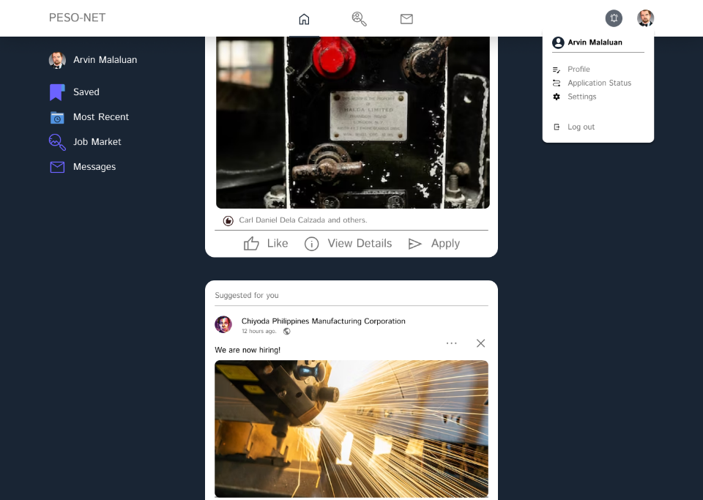

Figure 3. 14.

Home page for job seekers.

PESO-NET's home page for job seekers is designed to provide an intuitive and user-friendly experience, allowing job seekers to easily find and apply for job opportunities that match their skills and experience.

The home page features a clean and organized layout, with easy-to-navigate menus and search functions, enabling users to quickly access the information they need. The platform also provides personalized job recommendations and alerts, ensuring that job seekers stay up-to-date with the latest opportunities in their field. By providing an easy-to-use platform that is tailored to the needs of job seekers, PESO-NET's home page enables job seekers to confidently navigate the job market and take the next step in their career.

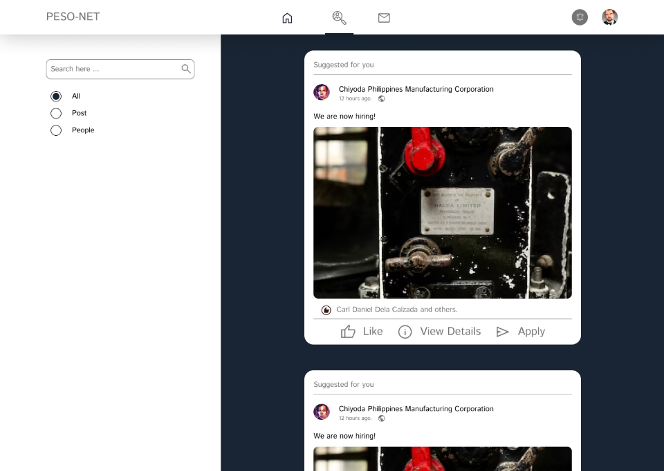

Figure 3. 15.

Job market for job recruiters.

The aim of PESO-NET's job market is to offer a hassle-free and productive job search process, enabling job seekers to effortlessly browse through various job options and utilize the platform's functions. With an interface that is simple to navigate and a robust search system, job seekers can promptly discover job vacancies that are pertinent to their abilities and preferences.

The platform's search functionality is powerful and efficient, enabling job seekers to quickly filter job listings based on various options such as all, post and people. This makes it easy for job seekers to find jobs and apply to those jobs directly through the platform. In addition to its search functionality, PESO-NET's job market also offers personalized job recommendations based on a job seeker's profile. This means that the platform takes into account a job seeker's qualifications, work experience, and career goals when suggesting job openings that may be a good fit. This feature saves job seekers time and effort by presenting them with relevant job opportunities without requiring them to sift through countless irrelevant listings.



Figure 3. 16.

Messenger for job seekers.

In the Messages section of the graphical user interface, users are able to communicate with potential employers, receive updates on their job applications, and stay connected with the job market. The messaging system is designed to be user-friendly and intuitive, allowing users to easily navigate through their conversations and keep track of important messages.

One of the key features of our messaging system is users can easily navigate through their conversations, filter them by job applications, and keep track of important messages. This means that they can spend less time trying to figure out how to use the messaging system and more time focusing on finding the right job for them. With PESO-NET's messaging system, job seekers can easily connect with potential employers, exchange messages, and stay up-to-date on the status of their job applications.

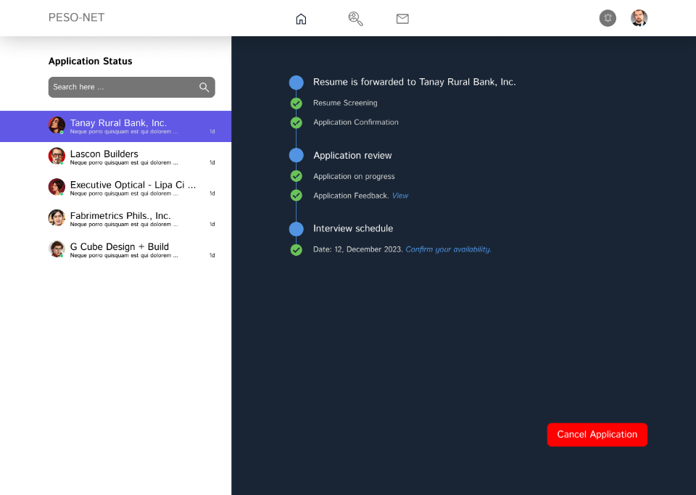

Figure 3. 17.

Application Tracking for Job Seekers.

The Application Tracking system enables users to monitor the status of their job applications. This feature provides applicants with real-time updates on their application status, keeping them informed throughout the hiring process.

Users can effortlessly check the progress of their applications and determine whether they are still pending, reviewed, or rejected. Additionally, they can also identify which applications have been shortlisted, giving them an idea of where they stand in the recruitment process. Another, you can cancel your application to the companies you applied for that can be seen on the left.

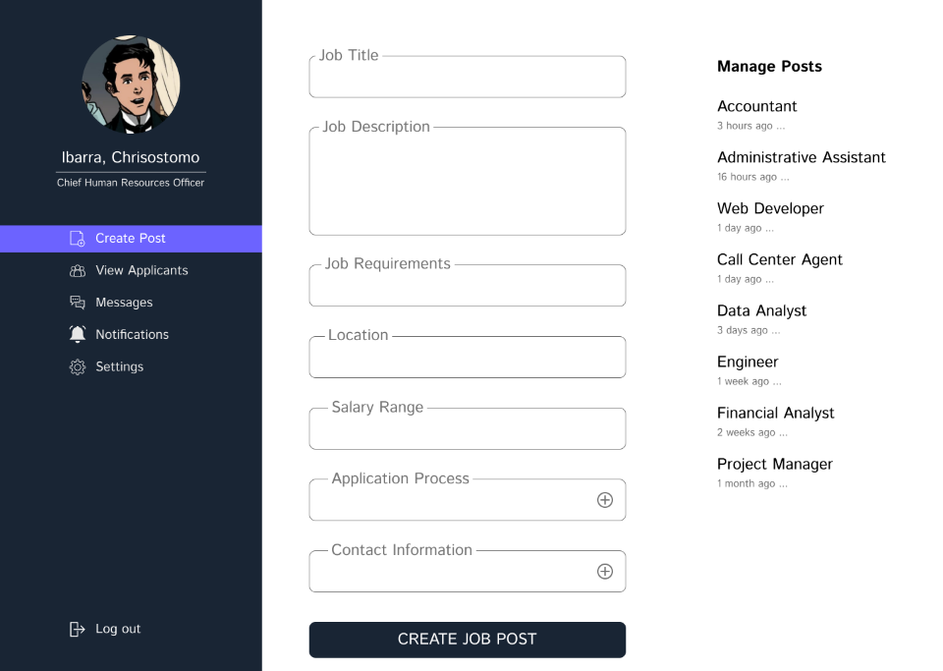

Figure 3. 18.

Create post page for job recruiter.

PESO-NET's Create posts page for job recruiters offers a simple and easy-to-navigate interface, enabling recruiters to quickly create and publish job postings in just a few clicks. The platform offers a range of features that allow recruiters to specify job requirements, set application deadlines, and even preview their posts before publishing them.

On our create post page, job recruiters can quickly and easily post job vacancies and attract top talent. The page is designed to be intuitive and easy to use, with a clean and simple layout that streamlines the process of creating job posts. Recruiters can input all the necessary details of the job, including job title, description, requirements, and location. They can also set the salary range and application process. Our platform also allows recruiters to preview their job posting before publishing it, ensuring that they have included all the necessary information and that the post is visually appealing and easy to read.

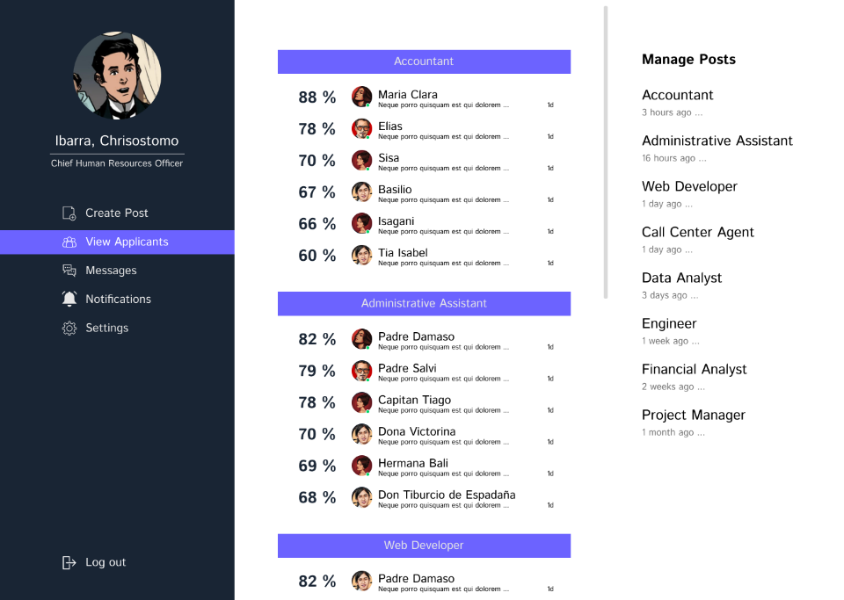

Figure 3. 19.

View applicants’ page for job recruiters.

PESO-NET's View Applicants page is designed to provide an intuitive and user-friendly experience for job recruiters who want to efficiently review and manage candidate applications. The page offers a simple and easy-to-use interface that allows recruiters to quickly navigate through the list of applicants, filter them by various criteria, and view their profiles and application details in a clear and organized manner.

View Applicants page is designed with advanced filtering and sorting options, you can quickly and easily identify the most qualified candidates for the job. Our user-friendly interface allows you to view detailed information about each candidate, including the percentage they are fitted to the job. And when you click a particular applicant, it would allow you to view their resume, cover letter, and application status.



Figure 3. 20.

Messenger for job recruiters.

The messenger interface is tailored to offer recruiters a smooth and hassle-free experience when communicating with potential job seekers. Its design is geared towards enabling recruiters to effectively evaluate job seeker's qualifications and move them seamlessly through the recruitment pipeline, ensuring a swift and efficient recruitment process.

Our Messenger interface is user-friendly, allowing recruiters to easily manage and respond to candidate messages in real-time. It also includes features such as read receipts, message archiving, and the ability to send attachments, making it easy for recruiters to keep track of conversations and share important documents. PESO-NET's Messenger is a powerful tool for job recruiters. It has been specifically designed to provide a seamless and efficient communication experience with candidates. The platform's Messenger is integrated directly into the recruitment process, enabling recruiters to communicate with candidates quickly and easily throughout the hiring process.



Figure 3. 21.

Notification Page for Job Recruiters.

The notification system on PESO-NET's platform enables recruiters to remain up-to-date with the latest candidate activity, preventing them from missing any significant updates. The notification page has been designed to prioritize simplicity, enabling recruiters to easily navigate and manage their notifications.

The job recruiters will receive notifications about new job postings and candidate applications in real-time. Our automated system ensures that recruiters are always in the loop, so they can focus on finding the best candidates for their organization. They can customize their notification settings to ensure that they only receive the information that's most relevant to them. And with our intuitive interface, they will be able to manage their notifications with ease, allowing them to stay organized and efficient.

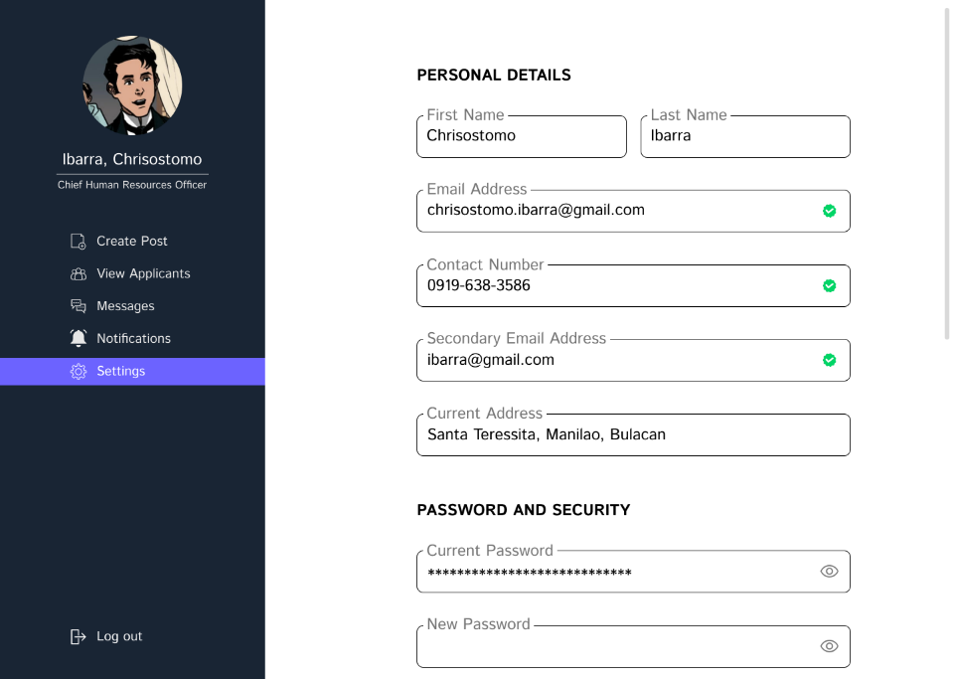

Figure 3. 22.

Settings for Job Recruiters.

This module’s purpose is specifically to edit job recruiter’s personal information. It is also designed to add/remove details and even change passwords.

The platform ensures that recruiters can keep their personal details up-to-date without any hassle. Whether it's a change of name, address, phone number, or email address, the "Settings" module makes it quick and easy for recruiters to make the necessary changes. One of the key benefits of the "Settings" module is its ability to add or remove specific details according to the recruiters' preferences. This feature ensures that the recruiters' information is always accurate and relevant, which is crucial for maintaining a professional image. Furthermore, the "Settings" module also offers the option to change passwords, allowing job recruiters to ensure the security of their accounts. This feature adds an extra layer of protection to the recruiters' accounts, ensuring that their personal and confidential information is always safe and secure.



Figure 3. 23.

Log in page for PESO Staff.

The login page for the PESO staff is separated from the login page of job recruiters and job seekers. This is to ensure that it will stay hidden from people who are attempting to exploit the system's vulnerabilities.

Having a separate login form for PESO staff adds an extra layer of protection to the system, as it restricts access to sensitive information and functionalities to authorized personnel only. With a dedicated login form for PESO staff, it is possible to define specific roles and permissions for different levels of access, ensuring that only those with the necessary credentials can make modifications to the system. This feature can be particularly useful for managing and monitoring the system's performance, security, and overall functionality.

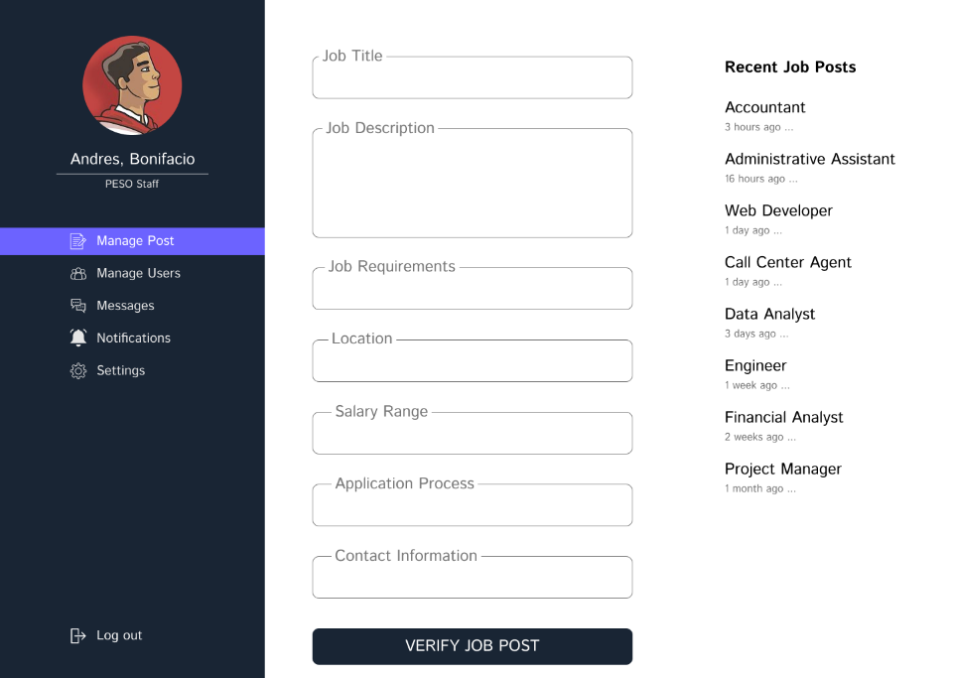

Figure 3. 24.

Manage Post for PESO Staff.

PESO-NET's manage posts page provides a convenient and efficient way for peso staff to oversee and manage the job postings on the platform. The page is designed with a user-friendly interface, allowing staff to easily filter and search for specific job postings and perform necessary actions such as editing or deleting them.

On the manage posts page, PESO staff can review job postings and ensure that they adhere to the agency's writing policies and guidelines. The page provides a centralized location for staff to manage all job postings, making it easy to keep track of each job and quickly make any necessary updates. Staff can also archive job postings once they have been filled or are no longer available.

By reviewing job postings on the manage posts page, PESO staff can ensure that the information provided is accurate and complete, and that the job requirements are clearly stated. This helps to maintain the integrity of the job search process and ensures that job seekers are presented with high-quality job opportunities. Additionally, staff can provide feedback to recruiters if a job posting does not meet the agency's writing policies, giving them the opportunity to make any necessary changes before it goes live.

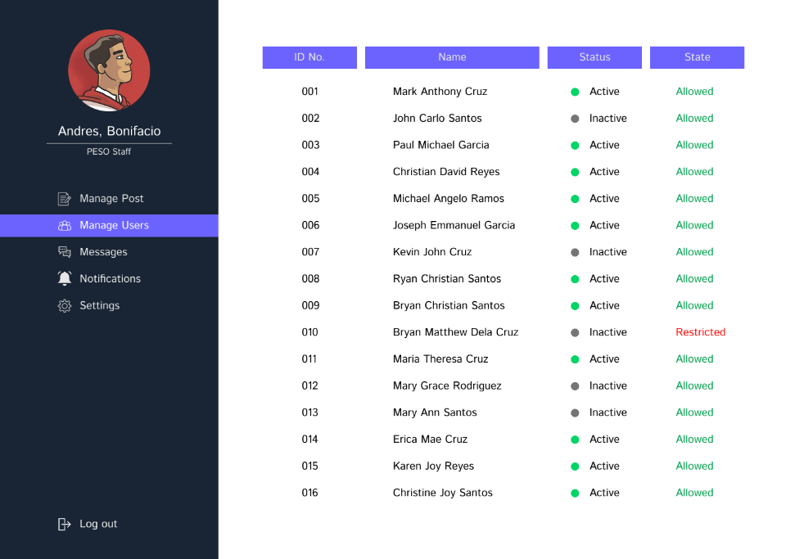

Figure 3. 25.

User Management Page for PESO Staff.

Managing users is a crucial aspect of the job of PESO staff, as it allows them to ensure that the platform is being used appropriately and that its users are having a positive experience. PESO-NET's manage users page offers a range of tools and features that enable staff to view and manage user accounts, monitor user activity, and take action when necessary. With this page, PESO staff can maintain a safe and secure platform that benefits all users.

On the manage users page, PESO staff have the ability to change the state of user accounts, providing them with control over the platform's user management process. This includes features such as activating or deactivating user accounts, managing user permissions, and reviewing user activity logs. By having this level of control, PESO staff can ensure the platform's security, maintain user compliance with platform guidelines, and address any issues or concerns that may arise. The manage users page serves as a valuable tool for PESO staff to effectively administer and govern user accounts on PESO-NET's platform.

Figure 3. 26.

Messenger for PESO Staff.

The messaging interface is specifically designed to provide PESO staff with an effortless and convenient means of communicating with users. Its interface is optimized to allow PESO staff to respond to user inquiries promptly and effectively using text messages.

We have developed a user-friendly Messenger interface that makes it easy for peso staff to manage and respond to messages from users in real-time. In addition to reading messages, message archiving, and the ability to send attachments, our Messenger interface helps recruiters keep track of conversations and share important documents. PESO-NET's Messenger is a powerful communication tool specifically designed to provide a seamless and efficient experience for peso staff to interact with users.



Figure 3. 27.

Notification Page for PESO Staff.

The notification feature in PESO-NET's platform allows the staff to stay informed about the latest activities of the users to avoid missing important updates. To ensure ease of use, the notification page has been designed to be simple and straightforward, allowing staff to easily navigate and manage their notifications.

The PESO staff members are alerted through the notification system of PESO-NET's platform for any new job postings to be verified quickly to provide job seekers and recruiters with a list of potential vacancies and candidates. The automated system guarantees that the PESO staff members are constantly updated, allowing them to concentrate on delivering the best job search experience for their users.

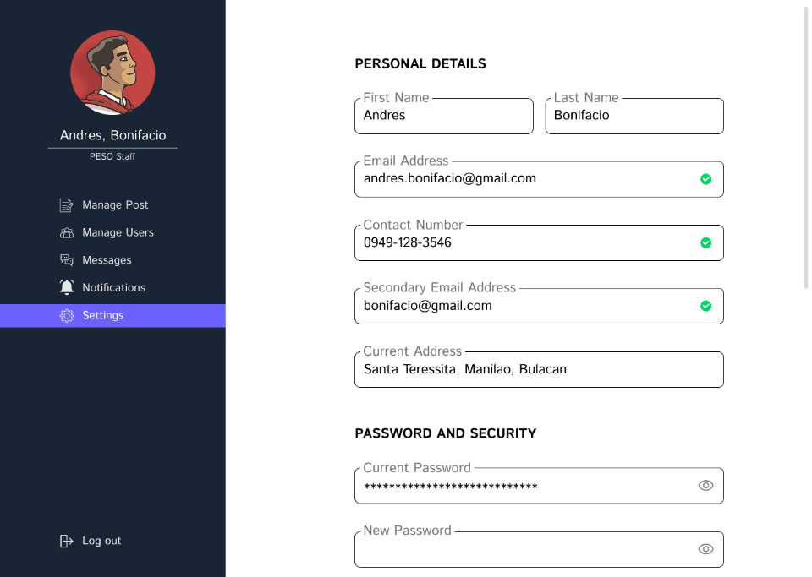

Figure 3. 28.

Settings for PESO Staff.

This module’s purpose is specifically to edit PESO staff’s personal information. It is also designed to add/remove details and even change passwords. The platform ensures that PESO staff can keep their personal details up-to-date without any hassle. Whether it's a change of name, address, phone number, or email address, the "Settings" module makes it quick and easy for PESO staff to make the necessary changes. One of the key benefits of the "Settings" module is its ability to add or remove specific details according to the recruiters' preferences. This feature ensures that the PESO staff's information is always accurate and relevant, which is crucial for maintaining a professional image. Furthermore, the "Settings" module also offers the option to change passwords, allowing them to ensure the security of their accounts. This feature adds an extra layer of protection to their accounts, ensuring that their personal and confidential information is always safe and secure.

# **BIBLIOGRAPHY**

*About PESO | DOLE | Bureau of Local Employment*. (2023). https://ble.dole.gov.ph/about-peso/

*About Public Employment Services (PES) | Department of Labor and Employment*. (n.d.). https://www.dole.gov.ph/public-employment-services-pes-contents/

*Advanced Analytics*. (n.d.). Gartner. Retrieved April 23, 2023, from https://www.gartner.com/en/information-technology/glossary/advanced-analytics#:~:text=Advanced%20Analytics%20is%20the%20autonomous,make%20predictions%2C%20or%20generate%20recommendations

Ahmad, S. Z., & Mahmood, S. (2015). Impact of online recruitment on job seekers: Evidence from Pakistan. Journal of Business Studies Quarterly, 7(3), 75-85.

Alsaif, S. A., Hidri, M. S., Ferjani, I., Eleraky, H. A., & Hidri, A. (2022). NLP-Based Bi-Directional Recommendation System: Towards Recommending Jobs to Job Seekers and Resumes to Recruiters. *Big Data and Cognitive Computing*, *6*(4), 147. https://doi.org/10.3390/bdcc6040147

Ambot, K. S. (2010). JOB PORTAL FOR DON MARIANO MARCOS MEMORIAL STATE UNIVERSITY. *E-International Scientific Research Journal*, *2*(3), 2094–1749. https://citeseerx.ist.psu.edu/document?repid=rep1&type=pdf&doi=5505e1b0205891989d457801c4c199b3a3ad2655&fbclid=IwAR2s3EOjXObEG7dUUcp9zL7QSGaXHm1iG9sWu5mK9D1Ni-zfeDdlFSEVNBo#page=33

Azeta, A. A., Ikhu-Omoregbe, N. A., Ayo, C. K., & Atayero, A. A. (2008). A Software Engineered Voice-Enabled Job Recruitment Portal System. European Journal of Scientific Research, 21(1), 95-103. Retrieved from http://eprints.covenantuniversity.edu.ng/39/1/ejsr%252021%25201.pdf

Bhaya, W. S. (2017). Review of Data Preprocessing Techniques in Data Mining. *ResearchGate*. https://doi.org/10.3923/jeasci.2017.4102.4107

Bhor, S., Gupta, V., Nair, V., Shinde, H., & Kulkarni, M. (2021). Resume Parser Using Natural Language Processing Techniques. *International Journal of Research in Engineering and Science*, *Volume 9*(Issue 6), 2320–9356. https://www.ijres.org/papers/Volume-9/Issue-6/Ser-8/A09060106.pdf

Bothmer, K., & Schlippe, T. (2022). Investigating Natural Language Processing Techniques for a Recommendation System to Support Employers, Job Seekers and Educational Institutions. In *Lecture Notes in Computer Science* (pp. 449–452). Springer Science+Business Media. https://doi.org/10.1007/978-3-031-11647-6_90

*Cleaning | Subject Profile | Union of International Associations*. (n.d.). https://uia.org/s/sub/en/1900000434/#:~:text=Cleaning%20is%20the%20process%20of,and%20uses%20many%20different%20methods.

Collection definition and meaning | Collins English Dictionary. (2023). In *Collins Dictionaries*. https://www.collinsdictionary.com/dictionary/english/collection

Coursera. (2023). Machine Learning Models: What They Are and How to Build Them. *Coursera*. Retrieved April 20, 2023, from https://www.coursera.org/articles/machine-learning-models

Dave, C. V., Goyal, D., & Singhal, G. (2021). Enhancement of the Online Job Portal Using Natural Language Processing. *International Journal of Advances in Engineering and Management (IJAEM)*, *3*(12), 2395–5252. https://ijaem.net/issue_dcp/Enhancement%20of%20the%20Online%20Job%20Portal%20Using%20Natural%20Language%20Processing.pdf

*Definition of Job Portals*. (2018, December). Career Trend. Retrieved April 20, 2023, from https://careertrend.com/facts-6883857-definition-job-portals.html

Delos Reyes, A. V., Crisostomo, G. P. S., & Hontiveros, R. J. D. (2014). JOB-SMGS: Online job application with job matching for Sanmaru Manpower and General Services. Asian Journal of Computer Science and Technology, 2(1), 110-114. Retrieved from https://ejournals.ph/function/reader1/read/web/viewer.php?id=uploads%2Farchive%2FANI%2FVol.+2+No.+1+%282015%29%2FCST%2F014_Delos+Reyes.pdf&di=10910%20make%20a%20RRL%20with%20APA%20in-text%20style%20citations%20and%20direct%20quotations

Department of Labor and Employment (DOLE). (2018). Implementing Guidelines on the New PhilJobNet Platform and PESO Employment Information System. Retrieved from https://www.dole.gov.ph/php_assets/uploads/2017/07/DO-165-16-Implementing-Guidelines-on-the-New-PhilJobNet-Platform-and-PESO-Employment-Information-Sys.pdf

*Efficient Natural Language Processing for Automated Recruiting on the Example of a Software Engineering Talent-Pool*. (2018). Retrieved May 9, 2023, from https://download.fortiss.org/public/pmwt/theses/Masterarbeit_TamasNeumer.pdf

Geneta, M. L., Atienza, G. C., Panopio, J. L., & Pesigan, A. R. (2019). Design and development of a web-based job portal for PESO Rosario. International Journal of Computer Applications, 181(45), 33-37. Retrieved from  http://www.ijarp.org/published-research-papers/june2019/Development-Of-Public-Employment-Service-Office-Job-Portal-For-Municipality-Of-Rosario-Batangas.pdf

Gil, J. M., Freudenthaler, B., & Natschläger, T. (2018). Recommendation of Job Offers Using Random Forests and Support Vector Machines. In *EDBT/ICDT Workshops* (pp. 22–27). https://doi.org/10.6084/m9.figshare.11901915

Gupta, A., & Jain, R. (2016). Role of online job portals in recruitment process: A study of select Indian cities. International Journal of Applied Research, 2(5), 241-245.

Habito, C. F. (2009). Promoting youth employment in the Philippines: policy and action project. A final independent evaluation report. Retrieved from https://www.ilo.org/wcmsp5/groups/public/---asia/---ro-bangkok/---ilo-manila/documents/publication/wcms_142966.pdf

International Labour Organization. (n.d.). Promoting Youth Employment in Asia and the Pacific. Retrieved from https://www.ilo.org/asia/publications/WCMS_609634/lang--en/index.htm

Jayachandran, A. (2020). E-RECRUITMENT: AN ADVANTAGE OVER TRADITIONAL RECRUITMENT. *ResearchGate*. https://www.researchgate.net/publication/355510484_E-RECRUITMENT_AN_ADVANTAGE_OVER_TRADITIONAL_RECRUITMENT

Kaharuddin, I. W. (2018). ANALYZING EMPLOYEESâ€TM PERCEPTION OF TRADITIONAL AND MODERN RECRUITMENT        | Jurnal EMBA : Jurnal Riset Ekonomi, Manajemen, Bisnis dan Akuntansi. *ejournal.unsrat.ac.id*. https://doi.org/10.35794/emba.6.4.2018.21664

Karakolis, E., Kapsalis, P., Skalidakis, S., Kontzinos, C., Kokkinakos, P., Markaki, O. I., & Askounis, D. (2022). Bridging the Gap between Technological Education and Job Market Requirements through Data Analytics and Decision Support Services. *Applied Sciences*, *12*(14), 7139. https://doi.org/10.3390/app12147139

Kelley, E. M., Ksoll, C., & Magruder, J. (2019). How do Online Job Portals affect Employment and Job Search? Evidence from India. Retrieved from https://are.berkeley.edu/~jmagruder/KKM.pdf

Matsuda, N., & Nomura, S. (2019). Fast, easy and cheap job matching: Social networks in Bangladesh. Journal of Development Studies, 55(7), 1444-1460. Retrived from https://openknowledge.worldbank.org/server/api/core/bitstreams/98e4c11d-3e70-5fc9-a02b-d0e4b830034e/content

Mills, T. (2018, July 2). What Is Natural Language Processing And What Is It Used For? *Forbes*. https://www.forbes.com/sites/forbestechcouncil/2018/07/02/what-is-natural-language-processing-and-what-is-it-used-for/?sh=64de85f15d71

Paramita, D. (2020). Digitalization in Talent Acquisition: A Case Study of AI in Recruitment. Retrieved from https://www.diva-portal.org/smash/get/diva2:1440107/FULLTEXT01.pdf

PwC. (2021). Creating fresh recruitment strategies to attract and retain remote workers. Retrieved from https://www.pwc.com/us/en/library/covid-19/creating-fresh-recruitment-strategies-to-attract-and-retain-remote-workers.html

Rąb-Kettler, K., & Lehnervp, B. (2019). Recruitment in the Times of Machine Learning. *Management Systems in Production Engineering*, *27*(2), 105–109. https://doi.org/10.1515/mspe-2019-0018

Ranjitha V, Swamydoss D. (2019). OB Portal System for Job Seeker and Companies. International Journal of Progressive Research in Science and Engineering, 5(2), 166-168. https://journals.grdpublications.com/index.php/ijprse/article/view/517/487

Reddy, D. J. M., Regella, S., & Seelam, S. R. (2020). *Recruitment Prediction using Machine Learning*. https://doi.org/10.1109/icccs49678.2020.9276955

Roh, Y., Heo, G., & Whang, S. E. (2021). A Survey on Data Collection for Machine Learning: A Big Data - AI Integration Perspective. *IEEE Transactions on Knowledge and Data Engineering*, *33*(4), 1328–1347. https://doi.org/10.1109/tkde.2019.2946162

Roy, P. K., Chowdhary, S. S., & Bhatia, R. (2020). A Machine Learning approach for automation of Resume Recommendation system. *Procedia Computer Science*, *167*, 2318–2327. https://doi.org/10.1016/j.procs.2020.03.284

Samson, J. (2021). The impact of COVID-19 on hiring practices: An empirical study. Journal of Human Resources Management Research, 2(1), 23-35. Retrieved from https://hrnation.ph/talent-acquisition-in-the-new-normal-recruitment-during-the-pandemic/

SHRM. (2020). COVID-19 drives technology adoption in talent acquisition. Retrieved from https://www.shrm.org/resourcesandtools/hr-topics/technology/pages/covid-19-drives-technology-adoption-in-talent-acquisition.aspx

Singh, J., & Singh, R. (2014). A study of online recruitment systems in India. International Journal of Emerging Research in Management &Technology, 3(3), 91-94.

Techopedia. (2022, May 11). *What is Data Set? - Definition from Techopedia*. https://www.techopedia.com/definition/3348/data-set-ibm-mainframe

Thowfeek, M. H., & Jahan, A. A. F. (2018). Online job portal system for Lanka jobs and marketing. Southeastern University Sri Lanka Repository. Retrieved from http://ir.lib.seu.ac.lk/handle/123456789/4817

Tiwari, R. (2023). The Impact of AI and Machine Learning on Job Displacement and Employment Opportunities. *Indian Scientific Journal of Research in Engineering and Management*, *07*(01). https://doi.org/10.55041/ijsrem17506

*Transforming our world: the 2030 Agenda for Sustainable Development | Department of Economic and Social Affairs*. (n.d.). Retrieved April 20, 2023, from https://sdgs.un.org/2030agenda

Trinh, Q. T., & Dang, T. (2022). Automatic Process Resume in Talent Pool by Applying Natural Language Processing. *ResearchGate*. https://www.researchgate.net/publication/358210364_Automatic_Process_Resume_in_Talent_Pool_by_Applying_Natural_Language_Processing

Trinidad, C. (2022). Philippine Peso (PHP). *Corporate Finance Institute*. https://corporatefinanceinstitute.com/resources/foreign-exchange/philippine-peso-php/

Upadhyay, S. (2023, February). *What Is An Algorithm? Characteristics, Types and How to write it*. Simplilearn. Retrieved April 20, 2023, from https://www.simplilearn.com/tutorials/data-structure-tutorial/what-is-an-algorithm

Vainikka, J. (2018). *Full-stack web development using Django REST framework and React*.

Vaughan, J. (2019). data. *Data Management*. Retrieved April 20, 2023, from https://www.techtarget.com/searchdatamanagement/definition/data

Vaughan, J. (2019). data. *Data Management*. Retrieved April 20, 2023, from https://www.techtarget.com/searchdatamanagement/definition/data

*What is analytics? What is business analytics? | Definition and types | SAP Insights*. (n.d.). SAP. Retrieved April 20, 2023, from https://www.sap.com/insights/what-is-analytics.html#:~:text=Analytics%20is%20a%20field%20of,share%20new%20insights%20and%20knowledge

*What is Machine Learning? | IBM*. (n.d.). Retrieved April 20, 2023, from https://www.ibm.com/topics/machine-learning

*What is Natural Language Processing?  | IBM*. (n.d.). Retrieved April 20, 2023, from https://www.ibm.com/topics/natural-language-processing#:~:text=the%20next%20step-,What%20is%20natural%20language%20processing%3F,same%20way%20human%20beings%20can

Xing, Y., Huang, J., & Lai, Y. (2019). Research and Analysis of the Front-end Frameworks and Libraries in E-Business Development. In *International Conference on Computer and Automation Engineering*. https://doi.org/10.1145/3313991.3314021